OPTION PRICING MODELS

**Submitted By:**

Monica Yadav

Shivam Singh

Shubhanjali Sharma

Jul 25, 2021

**Faculty Guide:**

Prof. Vineet Virmani



A CAPSTONE PROJECT

SUBMITTED IN PARTIAL FULFILLMENT OF THE REQUIREMENTS FOR THE ePGD ABA PROGRAMME

INDIAN INSTITUTE OF MANAGEMENT AHMEDABAD

OPTION PRICING MODELS

By: Monica Yadav, Shivam Singh, Shubhanjali Sharma

# Abstract

Its intuitiveness and the simplicity of its calculations make the seminal Black-Scholes-Merton option pricing model the most commonly known and used among all asset pricing models ever developed. Almost half a century after it was introduced, a massive literature has been devoted, and is still being generated, to empirical testing of the original model, to developing new models addressing its original assumptions and biases, and to extending the framework of option pricing. This report presents a review of fundamental option pricing models from Black-Scholes-Merton to the present day, covering alternative option pricing approaches, including those for options on different underlying assets as well as those with different asset price and volatility dynamics. This report also reviews Black Model, Fitting Second Order and Third Order Regression Models to compute IV, Monte Carlo Simulation and Heston Model, Pricing exotic options such as Barrier Options as well as implementation of novel methodologies from data science and statistics.

# Acknowledgment

We would like to express our sincere gratitude to our mentor and guide Prof. Vineet Virmani, Assistant Professor, Finance and Accounting Area | Indian Institute of Management, Ahmedabad for providing us an opportunity to work on this project.

Without their valuable guidance and timely support, this project would not have been completed. We would also like to extend a special thanks to the co-chairs of the e-PGD ABA program, Prof. Anish Sugathan, Assistant Professor, Indian Institute of Management Ahmedabad Business Policy Area and Prof. Anindya Chakrabarti as well as the rest of the faculty members of the ePGD ABA program who have helped us learn the concepts and techniques over the duration of this course which enabled us to complete this study.

Last but not the least, a special thanks to the e-PGD ABA program office, IIM Ahmedabad: Satish L M & Aliabbas Noorani for facilitating this capstone project.

Table of Contents

[Introduction 7](#_Toc109747584)

[Literature Review 9](#_Toc109747585)

[Modelling Volatility 11](#_Toc109747586)

[Numerical Methods 14](#_Toc109747587)

[Research Objectives 15](#_Toc109747589)

[Data Sources & Description 17](#_Toc109747590)

[Research and Problem-Solving Methodology 18](#_Toc109747591)

[Research Methodology 18](#_Toc109747592)

[Problem Solving Methodology 19](#_Toc109747593)

[Data Processing Workflow 21](#_Toc109747595)

[Analysis 23](#_Toc109747596)

[Data Processing 23](#_Toc109747597)

[Modelling 23](#_Toc109747598)

[Black Scholes Model: 23](#_Toc109747600)

[Newton Raphson Method: 25](#_Toc109747601)

[Black Model 25](#_Toc109747602)

[Volatility Smile 26](#_Toc109747603)

[Monte Carlo Simulation 27](#_Toc109747604)

[Heston Model 27](#_Toc109747605)

[Insights 30](#_Toc109747606)

[Conclusion 31](#_Toc109747607)

[Future Scope 32](#_Toc109747608)

[References 33](#_Toc109747609)

[Appendix 35](#_Toc109747610)

**List of Figures:**

[Figure 1 Matching Call Option Price for SBI using Black Scholes Model 34](https://d.docs.live.net/a466f0f4d1e74d28/Documents/Alisha/Capstone/Proposal%20to%20Report.docx" \l "_Toc78131130)

[Figure 2 Matching Put Option Price for SBI using Black Scholes Method 35](https://d.docs.live.net/a466f0f4d1e74d28/Documents/Alisha/Capstone/Proposal%20to%20Report.docx#_Toc78131131)

Figure 3 Matching Implied Volatility using Newton Raphson [36](https://d.docs.live.net/a466f0f4d1e74d28/Documents/Alisha/Capstone/Proposal%20to%20Report.docx#_Toc78131132)

Figure 4 Matching IV using Black Model [37](https://d.docs.live.net/a466f0f4d1e74d28/Documents/Alisha/Capstone/Proposal%20to%20Report.docx#_Toc78131133)

Figure 5 Comparing Black Scholes and Black Model IV [38](https://d.docs.live.net/a466f0f4d1e74d28/Documents/Alisha/Capstone/Proposal%20to%20Report.docx#_Toc78131134)

Figure 6 Comparing Option Prices using Black Scholes and Black Model [38](https://d.docs.live.net/a466f0f4d1e74d28/Documents/Alisha/Capstone/Proposal%20to%20Report.docx#_Toc78131135)

Figure 7 Comparing IV from Black Scholes vs Black Model [39](https://d.docs.live.net/a466f0f4d1e74d28/Documents/Alisha/Capstone/Proposal%20to%20Report.docx#_Toc78131136)

Figure 8 Comparing IV from Black Scholes vs Black Model for Put Option [40](https://d.docs.live.net/a466f0f4d1e74d28/Documents/Alisha/Capstone/Proposal%20to%20Report.docx#_Toc78131137)

Figure 9 Comparing Put Option Price for Black Scholes vs Black Model [40](https://d.docs.live.net/a466f0f4d1e74d28/Documents/Alisha/Capstone/Proposal%20to%20Report.docx#_Toc78131138)

Figure 10 Volatility Smile for Axis Bank Option [41](https://d.docs.live.net/a466f0f4d1e74d28/Documents/Alisha/Capstone/Proposal%20to%20Report.docx#_Toc78131139)

Figure 11 Volatility Smile for HDFC Bank Option [41](https://d.docs.live.net/a466f0f4d1e74d28/Documents/Alisha/Capstone/Proposal%20to%20Report.docx#_Toc78131140)

Figure 12 Volatility Smile for ICICI Bank Option [42](https://d.docs.live.net/a466f0f4d1e74d28/Documents/Alisha/Capstone/Proposal%20to%20Report.docx#_Toc78131141)

Figure 13 Volatility Smile for Infosys Option [42](https://d.docs.live.net/a466f0f4d1e74d28/Documents/Alisha/Capstone/Proposal%20to%20Report.docx#_Toc78131142)

Figure 14 Volatility Smile for ITC Option [43](https://d.docs.live.net/a466f0f4d1e74d28/Documents/Alisha/Capstone/Proposal%20to%20Report.docx#_Toc78131143)

Figure 15 Volatility Smile for Airtel Option [43](https://d.docs.live.net/a466f0f4d1e74d28/Documents/Alisha/Capstone/Proposal%20to%20Report.docx#_Toc78131144)

Figure 16 Volatility Smile for Bajaj Finance Option [44](#_bookmark27)

Figure 17 Volatility Smile for Indigo Option [44](#_bookmark33)

Figure 18 Volatility Smile for NTPC Option [45](#_bookmark34)

Figure 19 Volatility Smile for Tata Motors Option [45](https://d.docs.live.net/a466f0f4d1e74d28/Documents/Alisha/Capstone/Proposal%20to%20Report.docx#_Toc78131148)

Figure 20 Axis Bank IV Quadratic Fit [46](https://d.docs.live.net/a466f0f4d1e74d28/Documents/Alisha/Capstone/Proposal%20to%20Report.docx#_Toc78131149)

Figure 21 HDFC Bank IV Quadratic Fit [46](https://d.docs.live.net/a466f0f4d1e74d28/Documents/Alisha/Capstone/Proposal%20to%20Report.docx#_Toc78131130)

Figure 22 ICICI Bank IV Quadratic Fit [46](https://d.docs.live.net/a466f0f4d1e74d28/Documents/Alisha/Capstone/Proposal%20to%20Report.docx#_Toc78131131)

Figure 23 Infosys IV Quadratic Fit [46](https://d.docs.live.net/a466f0f4d1e74d28/Documents/Alisha/Capstone/Proposal%20to%20Report.docx#_Toc78131132)

Figure 24 ITC IV Quadratic Fit [47](https://d.docs.live.net/a466f0f4d1e74d28/Documents/Alisha/Capstone/Proposal%20to%20Report.docx#_Toc78131133)

Figure 25 Airtel IV Quadratic Fit [47](https://d.docs.live.net/a466f0f4d1e74d28/Documents/Alisha/Capstone/Proposal%20to%20Report.docx#_Toc78131134)

Figure 26 Bajaj Finance IV Quadratic Fit [47](https://d.docs.live.net/a466f0f4d1e74d28/Documents/Alisha/Capstone/Proposal%20to%20Report.docx#_Toc78131135)

Figure 27 Indigo IV Quadratic Fit [47](https://d.docs.live.net/a466f0f4d1e74d28/Documents/Alisha/Capstone/Proposal%20to%20Report.docx#_Toc78131136)

Figure 28 NTPC IV Quadratic Fit [48](https://d.docs.live.net/a466f0f4d1e74d28/Documents/Alisha/Capstone/Proposal%20to%20Report.docx#_Toc78131137)

Figure 29 Tata Motors IV Quadratic Fit [48](https://d.docs.live.net/a466f0f4d1e74d28/Documents/Alisha/Capstone/Proposal%20to%20Report.docx#_Toc78131138)

Figure 30 Axis Bank IV Third Order Polynomial Fit [49](https://d.docs.live.net/a466f0f4d1e74d28/Documents/Alisha/Capstone/Proposal%20to%20Report.docx#_Toc78131139)

Figure 31 HDFC Bank IV Third Order Polynomial Fit [49](https://d.docs.live.net/a466f0f4d1e74d28/Documents/Alisha/Capstone/Proposal%20to%20Report.docx#_Toc78131140)

Figure 32 ICICI Bank IV Third Order Polynomial Fit [49](https://d.docs.live.net/a466f0f4d1e74d28/Documents/Alisha/Capstone/Proposal%20to%20Report.docx#_Toc78131141)

Figure 33 Infosys IV Third Order Polynomial Fit [49](https://d.docs.live.net/a466f0f4d1e74d28/Documents/Alisha/Capstone/Proposal%20to%20Report.docx#_Toc78131142)

Figure 34 ITC IV Third Order Polynomial Fit [50](https://d.docs.live.net/a466f0f4d1e74d28/Documents/Alisha/Capstone/Proposal%20to%20Report.docx#_Toc78131143)

Figure 35 Airtel IV Third Order Polynomial Fit [50](https://d.docs.live.net/a466f0f4d1e74d28/Documents/Alisha/Capstone/Proposal%20to%20Report.docx#_Toc78131144)

Figure 36 Bajaj Finance IV Third Order Polynomial Fit [50](#_bookmark27)

Figure 37 Indigo IV Third Order Polynomial Fit [50](#_bookmark33)

Figure 38 NTPC IV Third Order Polynomial Fit [51](#_bookmark34)

Figure 39 Tata Motors IV Third Order Polynomial Fit [51](https://d.docs.live.net/a466f0f4d1e74d28/Documents/Alisha/Capstone/Proposal%20to%20Report.docx#_Toc78131148)

Figure 40 Option Pricing using Monte Carlo Simulation Method [52](https://d.docs.live.net/a466f0f4d1e74d28/Documents/Alisha/Capstone/Proposal%20to%20Report.docx#_Toc78131149)

# Introduction

A **derivative** can be defined as a financial instrument whose value depends on (or derives from) the values of other, more basic, underlying variables. Very often the variables underlying derivatives are the prices of traded assets [1]. The derivatives can be categorized into different categories based on their complexity or hedging needed. For instance, a future is a simple derivative, while exotic options fall under complex derivatives. However, a more useful way to categorize derivatives is to separate them into two broad categories: Linear, and Non-Linear derivatives. A linear derivative is easier to hedge and lock in. On the other hand, a non-linear derivative has inherent instability and requires dynamic hedging.

**Options** are non-linear derivatives as they depend on a variety of characteristics, including implied volatility, time to maturity, underlying asset price, and the current interest rate. Options are versatile financial products that give the right (but not the obligation) to buy or sell stocks at an agreed price (strike price) on or before a particular date (expiration date). In simple terms, options are traded lotteries in financial markets. An American Option is one that can be exercised anytime until the expiration date while a European Option can be exercised on a specified future date. Bermudan option is a hybrid, it can be exercised on a set number of days between inception and expiration

There are two types of options:

(i) **Call** Option: Gives option holder the right (but not the obligation) to buy shares of stock, at an agreed upon price, on or before an expiration date

(ii) **Put** Option: Gives option holder the right (but not the obligation) to sell shares of stock, at an agreed upon price, on or before an expiration date

Intrinsic value for the call option is the positive difference between the asset value and the strike price. If the difference between them is negative, the intrinsic value becomes zero.

Derivatives market has expanded exponentially globally in terms of the variety of instruments available and also complexity and turnover. India’s journey with derivatives began in 2000, with index futures launched in June 2000 being the first type of derivative. Index options were launched in June 2001, while options in individual stocks were launched in July 2001. The turnover of derivatives on NSE increased from Rs. 24 Bn in 2000-01 to Rs 292Tn in 2010-11, in the first decade and have only rinse since.[2]

In terms of exchange-traded derivatives, India is one of the most successful developing nations. The bedrock of this rests on the strength of the technological and modern advancements in India’s security markets, namely, nationwide market access, anonymous electronic trading, and a predominantly retail market. NSE is well positioned in terms of the number of trades in the derivatives segment, among all large exchanges globally for several products.

|  |  |
| --- | --- |
| Segment | Rank |
| Single Stock Options | 8 |
| Single Stock Futures | 2 |
| Stock Index Options | 1 |
| Long-term interest rate options and futures | 8 |
| Currency options and future contracts | 1 |

*Table 1: Rank of NSE in Different Derivatives Segments (2018) Source: 2018 IOMA Derivatives Market Survey*

*Note: Only WFE members exchanges are considered while ranking the exchanges. The ranking is done based on the total number of contracts traded in the exchange*

As per the latest data, May 2022-23, the total volume of index options was 47,33,62,809 (number of contracts) with a value of Rs. 4,14,09,406.45 Cr, and premium turnover of Rs. 1,24,708.79 Cr. The total volume of stock options was 71,91,977 (number of contracts) with a value of Rs. 5,19,119.88 Cr and premium turnover of Rs. 10,301.19 Cr

# Literature Review

Option Valuation

The price of an option can be determined by various factors including the current stock price, expiration date, volatility, interest rate, etc. The price is primarily made up of two parts: its intrinsic value and time value. Intrinsic value is a measure of the profitability of an option based on the strike price vs the stock's price in the market. Time value is based on the underlying asset's expected volatility and the time until the expiration of the contract.

The Black-Scholes model is a mathematical model based on a differential equation and is widely used to price options contracts. It was published in 1973 by economists Fischer Black and Myron Scholes. Though usually accurate, the Black- Scholes model makes the following assumptions:

* No dividends are paid out during the life of the option.
* Markets are random (i.e., market movements cannot be predicted).
* Markets are frictionless (i.e., there are no transaction costs, adjustment costs, etc. in buying the option) [4].
* The risk-free rate and volatility of the underlying asset are known and constant.
* The returns on the underlying asset are log-normally distributed and their variance remains constant (Geometric Brownian Motion) [3].
* The option is European and can only be exercised at expiration

𝐶 = 𝑁(𝑑1)𝑆𝑡 − 𝑁(𝑑2)𝐾𝑒−𝑟𝑡

Where,

$$d1=(ln{\frac{S}{K}+(r+ σ^{2})t))/σ\sqrt{t}}$$

$$d2=d1- σ√t$$

And,

C = Call option price

N = CDF of the normal distribution St = Spot price of an asset

K = Strike price

r = Risk-free interest rate t = Time to maturity

σ = Volatility of the asset

While the original Black-Scholes model did not consider the effects of dividends paid during the life of an option, the model has been frequently adapted to account for dividends by determining the [ex-dividend](https://www.investopedia.com/terms/e/ex-dividend.asp) date value of the underlying stock. The model has also been modified by many option-selling market makers to account for the effect of options that can be exercised before expiration. Black’s model (in 1976, also known as Black 76) was Fischer’s Black adjustment to his earlier Black-Scholes model and useful for pricing options derived from future contracts. It assumes constant volatility. The Black model equation is simpler with fewer terms.

As the markets have seen more & more shocks, they have also seen more sophisticated patterns of volatility contrary to the Black-Scholes-theory where the only source of randomness was the asset price. Since the “Black Monday” market crash of 1987, it has been noticed that the volatility of an option has become skewed towards the strike price and expiration. This relationship between the implied volatility of an option and its strike price is termed as Volatility Smiles. The implied volatility follows a convex behaviour and is lower for at-the-money (ATM) options (i.e., when the strike price is equal to the current market price). It becomes progressively higher as the strike price increases or decreases and goes towards in-the- money (ITM) or out-of-the-money (OTM). For some underlying assets, the volatility decreases as the strike price increases, weighing

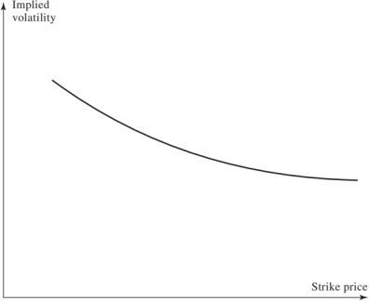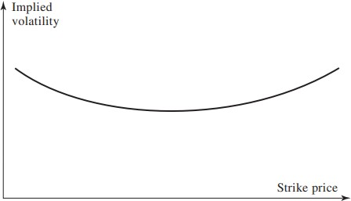the graph to one side and is known as “volatility smirk”.

Figure 2 Volatility Smirk

Figure 1 Volatility Smile

One of the explanations behind the volatility smirk is as and when a company’s equity declines, its borrowings/leverage increases and it becomes riskier, increasing its volatility. If the equity increases, its volatility decreases. The volatility smile can be used to determine the probability distribution of an asset price, known as the implied distribution. Traders consider that the lognormal distribution (the assumption of Black-Scholes-Merton model) understates the extreme movements in the market and the implied distribution has a heavier tail & a higher peak than a lognormal distribution, and thus we expect it to give a higher price with higher volatility.

## Modelling Volatility

Static models have no internal history of the past values of the input or output variables. The output variable is a function of the input variables provided at that instant, thus the output being similar to a snapshot in time, only depending on the current set of inputs. On the contrary, a dynamic model’s output would also be dependent on all the past input values given to the model, which it stores in its

memory. Some of the early static models incorporating the smile, the local volatility models, modelled volatility as a function of the stock price and time t. These models have a simplifying assumption that the volatility is an average of several instantaneous volatilities, derived by Derman & Kani in 1998. Local volatility models face computation challenges while generating smooth continuous volatility surfaces from just a few discrete option prices. They also lack the omnipresent nature of the skewness of the smile well into the future.

In an attempt to overcome the shortcomings of the Black Scholes model, researchers developed variations of the DVF (deterministic volatility function) option valuation models. In the research by Dumas, Fleming and Whaley, it was found that the DVF approach failed as they moved seven days into the future, the ability of the volatility function to price options fails markedly and also had large errors making it futile for hedging options. Their findings showed that volatility can’t be considered deterministic.

The stochastic volatility models assume the volatility to be made of a mixture of high and low volatility evolutions, fluctuating but following a long-term mean. This produces a more realistic smile compared to the low volatility models but adds up to the unknown factor because of the stochastic nature. It implies that the volatility is auto-correlated as opposed to the jump-diffusion models, where after a jump the volatility of the does not change.

There are various stochastic models for option pricing, like the SABR model, the Chen model, the GARCH model. Steve Heston, a finance professor, developed another popular stochastic model in 1993 known as the Heston model. The Heston model takes into account a possible correlation between the stock price and the volatility and does not assume that the stock price follows a lognormal distribution. It is a closed-form solution that seeks to overcome the shortcomings of Black-Scholes model. The Heston model takes two functions: Brownian motion, the underlying asset price, and the variance of the variance.[4] Using a few equations on Brownian motion corresponding to the underlying asset’s price and instantaneous variance, Heston came up with the following formula to calculate the price for a European call option having nine inputs:

dSt = rSt dt+ √Vt St dW1t

dVt = k(θ−Vt)dt + σ √Vt dW2t

St = asset price at time t

r = risk-free interest rate

Vt =volatility (standard deviation) of the asset price

σ = volatility of the Vt

θ = long-term price variance

k = rate of reversion to θ

dt = indefinitely small positive time increment

W1t = Brownian motion of the asset price

W2t = Brownian motion of the asset’s price variance

The Heston model agrees more with the observed data in the market and researchers have found it to be more accurate for medium-term and long-term maturity options. For short-term maturity options, Heston fails to capture the volatility smile. Also, the model is parameter sensitive and is subjective to the optimizer used [5].

Above discussed models are a few ways volatility has been modelled in the market but the choice of model depends on how your market behaves. For example, in the case of an FX market, the volatility is highly varying, making stochastic volatility models the preferred choice while in the case of interest rate options corresponding to central banks having lower volatility, local volatility models would be the way to go.

## Numerical Methods

Monte Carlo is another algorithm in quantitative finance used to simulate a series of random variables which have properties similar to the risks, option prices, etc. with probabilities. In the continuous time, there is an infinite number of time points between two points in time. Therefore, each variable carries a particular value at each point in time. Under this scenario, we will use the Geometric Brownian Motion of the stock price which implies that the stock follows a random walk. In the Geometric Brownian Motion model, we can specify the formula for stock price change [6]:

## ∆𝑆 = 𝑆(𝜇∆𝑡 + 𝜎𝜀√∆𝑡)

S = Stock Price

∆𝑆 = Change in Stock Price

𝜇 = Expected Return t = Time

𝜎 = Standard Deviation of Stock Price

𝜀 = Random Variable

In continuous time simulation, it is not needed to simulate the stock price in each period, but only at maturity, S(T), using the following formula. Random numbers are generated to solve for S(T).

$$S\left(T\right)=Se^{\left(r-δ-0.5σ^{2}\right)T + σs√t}$$

# Research Objectives

We examine the NSE option prices on by using a sample of matched high-frequency data of over a few thousand option contracts consisting of the unique SSO’s and the Nifty index options. We use a stochastic volatility model to model the volatility and match the option prices. To match the prices, we match the conformity of observed option prices to a parsimonious smile-adjusted Black model. We will estimate the smile for each underlying day, we will use a quadratic function, as it is the lowest order smile that can capture the two most important departures from lognormality observed in financial markets - fatter tails and skewness. A higher order smile might be closer to the market prices but runs the risk of overfitting [7].

We will estimate implied volatility and delta using Black’s model to eliminate the dividend yield estimation and cost-of-carry issues. We identify the best-fitted model by recursively minimizing the sum of the squared pricing errors between the market prices of the options and the prices using implied volatility from the volatility smile. The pricing errors will be calculated as the absolute difference between the market price of the option and the estimated price from the volatility smile.

The best-fitted model thus obtained will be extended to exotic options following the same approach as above to calculate the pricing errors. This model will be compared with Black-Scholes model in terms of improvements and the performance

on the said days. In doing that, the research aims to challenge the two inherent assumptions of the Black Scholes model - constant volatility and log normal distribution. This research will also attempt to give an informative view on whether the discrepancies in option prices occur as a result of the market mispricing or because of incorrect theoretical assumptions of the Black–Scholes model. This study does not intend to forecast the option prices. This study also does not venture into actively coming up with trading strategies.

# Data Sources & Description

All the datasets used for this analysis are secondary data. The table below explains the objective of choosing the kind of data, the data source, and the kind of features that were used from the dataset.

|  |  |
| --- | --- |
| Data | **Option Chain** |
| Source | https://www.nseindia.com/option-chain |
| Description:  This dataset was collected for certain stock options such as SBI, ICICIC, collected by the National Stock Exchange. | |
| Variables: OI, CHNG IN OI, VOLUME, IV, LTP, CHNG, BID, QTY, BID PRICE, ASK PRICE, ASK QTY, STRIKE PRICE | |

# Research and Problem-Solving Methodology

## Research Methodology

The National Stock Exchange captures the Option Chain Data for Indian Stock Market. This data is comprised of an option, its expiration date and attributes related to that option (such as IV, Strike Price etc.) This data is collected for ten such options (Axis Bank, HDFC, ICICI, Infosys, ITC, Bajaj Finance, Airtel, Indigo, NTPC, Tata Motors). This data is updated frequently throughout the day as the price change regularly.

Attributes such as Spot Price, Strike Price, Time to maturity, Interest Rate and Sigma from this data will be used to find the option price using Black Scholes Model. We will match the prices given in the data and prices which we get after putting above parameters in Black Scholes formula. After this we are going to use Newton Raphson method to match Implied Volatility given in this data for both call and put options. Later we will be using Black Model to find option pricing and comparing it with Black Scholes model in terms of IV and LTP, Assuming no Dividends. We will also be plotting volatility smiles for above options and fitting a second order and a third order polynomial regression model. We will also be using Monte Carlo Simulation method to compute call and put option prices and comparing it with Black Scholes Method.

--------------ADD TEXT----------------

## 

## Problem Solving Methodology

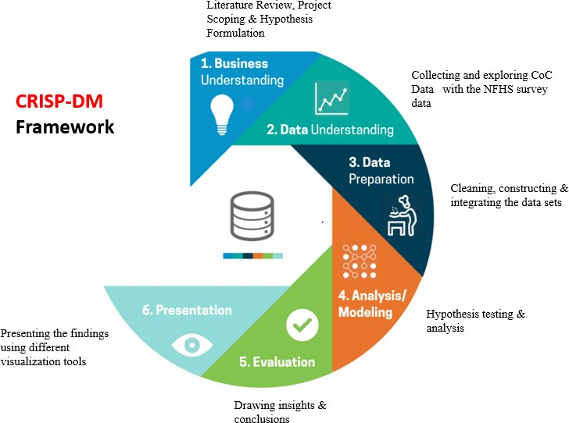

*Figure 1 Crisp-DM Framework*

Analytics problem solving involves multiple steps like data cleaning, preparation, modelling, model evaluation etc. Completing a typical analytics project may take several months, and thus it is important to follow a planned structure to accomplish it. The structure for analytics problem solving used in this project is the CRISP-DM framework - Cross Industry Standard Process for Data Mining (Shearer, 2000).

The CRISP-DM framework has been used to formulate the analysis plan over the course of 8 weeks. A thorough review of past literature played a substantial role in the business understanding of the problem, setting the scope of this project & formulating the hypotheses. Data was collected from Nation Stock Exchange website. After the data collection, data cleaning and preparation was done using tools such as Tableau & Python. Later models were run on this data and after careful evaluation, insights were provided.

# Data Processing Workflow

This study expands across two major areas of research, i.e., finance and statistics. To get meaningful insights out of these data processing was required. First the dataset was downloaded from NSE India Website on a frequently basis and data quality checks were also applied. Since the objective of this study was to use stochastic volatility models to better predict the Implied Volatility of Options and matching the option prices. Data for various options were downloaded and cleaned by removing the Nulls and Missing Values. This cleaned data was used as an input to various models. Later insights were generated from this data such as IV from various models, prices from various models. This data is also used to plot various volatility smile plots for different options and later second order and third regression were fitted on this data

# Analysis

Different analysis methods were utilized, to substantiate our hypothesis. Firstly, data was processed and cleaned using Python. Secondly this processed data was used as an input for our various stochastic models. Lastly insights were generated from the output given by these models

## Data Processing

Data Quality checks such as presence of symbols, nulls, removing duplicate values was applied to the data downloaded from NSE website. This was done for multiple option such as ICICI, Axis Bank etc. Later this data is fed into various stochastic models as an input.

## Modelling

## The pre-processed data was used as an input to various stochastic models such as Black Scholes Model, Newton Raphson, Black Model, Heston Model etc. The whole objective of applying these models is to better predict the volatility and match option prices.

## Black Scholes Model:

* The Black-Scholes model, aka the Black-Scholes-Merton (BSM) model, is a differential equation widely used to price options contracts.
* The Black-Scholes model requires five input variables: the strike price of an option, the current stock price, the time to expiration, the risk-free rate, and the volatility.
* Though usually accurate, the Black-Scholes model makes certain assumptions that can lead to predictions that deviate from the real-world results.
* The standard BSM model is only used to price European options, as it does not take into account that American options could be exercised before the expiration date.

Black-Scholes Assumptions

* No dividends are paid out during the life of the option.
* Markets are random (i.e., market movements cannot be predicted).
* There are no transaction costs in buying the option.
* The [risk-free rate](https://www.investopedia.com/terms/r/risk-freerate.asp) and volatility of the underlying asset are known and constant.
* The returns of the underlying asset are normally distributed.
* The option is [European](https://www.investopedia.com/terms/e/europeanoption.asp) and can only be [exercised](https://www.investopedia.com/ask/answers/06/excerciseonexpiration.asp) at expiration.

𝐶 = 𝑁(𝑑1)𝑆𝑡 − 𝑁(𝑑2)𝐾𝑒−𝑟𝑡

Where,

$$d1=(ln{\frac{S}{K}+(r+ σ^{2})t))/σ\sqrt{t}}$$

$$d2=d1- σ√t$$

Drawbacks:

The Black-Scholes model is only used to price European options and does not take into account that U.S. options could be exercised before the expiration date. Moreover, the model assumes dividends and risk-free rates are constant, but this may not be true in reality. The model also assumes [volatility remains constant](https://www.investopedia.com/ask/answers/060115/how-implied-volatility-used-blackscholes-formula.asp) over the option's life, which is not the case because volatility fluctuates with the level of supply and demand.

Additionally, the other assumptions—that there are no transaction costs or taxes; that the risk-free interest rate is constant for all maturities; that short selling of securities with use of proceeds is permitted; and that there are no risk-less arbitrage opportunities—can lead to prices that deviate from the real world's.

## Newton Raphson Method:

The Newton-Raphson method, or Newton Method, is a powerful technique for solving equations numerically. Like so much of the differential calculus, it is based on the simple idea of linear approximation. The Newton Method, properly used, usually homes in on a root with devastating efficiency. We have used Newton Raphson Method to match Implied Volatility.

Let f(x) be a well-behaved function, and let r be a root of the equation f(x) = 0. We start with an estimate x0 of r. From x0, we produce an improved—we hope—estimate x1. From x1, we produce a new estimate x2. From x2, we produce a new estimate x3. We go on until we are ‘close enough’ to r—or until it becomes clear that we are getting nowhere. The above general style of proceeding is called iterative. Of the many iterative root-finding procedures, the Newton-Raphson method, with its combination of simplicity and power, is the most widely used.

## Black Model

Black's Model, sometimes called Black-76, is an adjustment of his earlier and more famous [Black-Scholes](https://www.investopedia.com/terms/b/blackscholes.asp) options pricing model. Unlike the earlier model, the revised model is useful for valuing options on [futures contracts](https://www.investopedia.com/terms/f/futurescontract.asp). Black's Model has also been used in the application of capped variable rate loans and is also applied to price a variety of others derivatives.

* Black's Model, also known as the Black 76 Model, is a versatile derivatives pricing model for valuing assets such as options on futures and capped variable rate debt securities.
* The model was developed by Fischer Black by elaborating on the earlier and more well-known Black-Scholes-Merton options pricing formula.
* Like other financial models, Black 76 relies on several assumptions, such as a log-normal distribution of prices and zero trading costs - some of which are more realistic than others.

Assumptions:

Black’s 76 model makes several assumptions, including that future prices, are log-normally distributed and that the expected change in futures price is zero. One of the key differences between his 1976 model and the Black-Scholes model (which assumes a known risk-free interest rate, options that can only be exercised at maturity, no commissions and that volatility is held constant), is that his revised model uses forward prices to model the value of a futures option at maturity versus the spot prices Black-Scholes used. It also assumes that volatility is dependent on time, rather than being constant.

## Volatility Smile

A [volatility smile](https://www.investopedia.com/terms/v/volatilitysmile.asp) is a geographical pattern of [implied volatility](https://www.investopedia.com/terms/i/iv.asp) for a series of options that has the same expiration date. When plotted against strike prices, these implied volatilities can create a line that slopes upward on either end; hence the term "smile." Volatility smiles should never occur based on standard Black-Scholes option theory, which normally requires a completely flat volatility curve. The first notable volatility smile was seen following the 1987 [stock market](https://www.investopedia.com/terms/s/stockmarket.asp) crash.

The [pricing of options](https://www.investopedia.com/articles/optioninvestor/07/options_beat_market.asp) is more complicated than the pricing of stocks or commodities, and this is well-reflected in a volatility smile. Three main factors make up an option's value: [strike price](https://www.investopedia.com/terms/s/strikeprice.asp) relative to the [underlying asset](https://www.investopedia.com/terms/u/underlying-asset.asp); the time until expiration, or expiry; and the expected volatility in the underlying asset during the life of the option. Most option valuations rely on the concept of implied volatility, which assumes the same level of volatility exists for all options of the same asset with the same expiry.

Several hypotheses explain the existence of volatility smiles. The simplest and most obvious explanation is that demand is greater for options that are in-the-money or out-of-the-money as opposed to at-the-money options. Others suggest that better-developed options models have led to out-of-the-money options becoming priced more expensively to account for risk of extreme market crashes or [black swans](https://www.investopedia.com/terms/b/blackswan.asp). This calls into question any investing strategy that relies too heavily on implied volatility from the [Black-Scholes model](https://www.investopedia.com/terms/b/blackscholes.asp), particularly with the [valuation](https://www.investopedia.com/terms/v/valuation.asp) of downside puts that are far away from the money.

## Monte Carlo Simulation

Monte Carlo methods can be used in finance to analyse the value of an option with multiple sources of uncertainty. First, the price of the underlying asset is simulated by random number generation for a number of paths or trajectories. After repeatedly simulating the trajectories and computing appropriate averages, the estimated price of options can be obtained, which is consistent with the analytical results from Black-Scholes model.

## Heston Model

The Heston Model, developed by associate finance professor Steven Heston in 1993, is an option pricing model that can be used for pricing [options](https://www.investopedia.com/terms/o/option.asp) on various securities. It is comparable to the more popular [Black-Scholes option pricing model](https://www.investopedia.com/terms/b/blackscholes.asp).

Overall, option pricing models are used by advanced investors to estimate and gauge the price of a particular option, trading on an underlying security in the financial marketplace. Options, just like their underlying security, will have prices that change throughout the trading day. Option pricing models seek to analyse and integrate the variables that cause fluctuation of option prices in order to identify the best option price for investment.

As a [stochastic volatility](https://www.investopedia.com/terms/s/stochastic-volatility.asp) model, the Heston Model uses statistical methods to calculate and forecast option pricing with the assumption that volatility is arbitrary. The assumption that volatility is arbitrary, rather than constant, is the key factor that makes stochastic volatility models unique. Other types of stochastic volatility models include the SABR model, the Chen model, and the [GARCH](https://www.investopedia.com/terms/g/generalalizedautogregressiveconditionalheteroskedasticity.asp) model.

Differences:

The Heston Model has characteristics that distinguish it from other stochastic volatility models, namely:

* It factors in a possible correlation between a stock's price and its volatility.
* It conveys volatility as reverting to the mean.
* It gives a closed-form solution, meaning that the answer is derived from an accepted set of mathematical operations.
* It does not require that stock prices follow a lognormal probability distribution.

Formula

dSt = rSt dt+ √Vt St dW1t

dVt = k(θ−Vt)dt + σ √Vt dW2t

St = asset price at time t

r = risk-free interest rate

Vt =volatility (standard deviation) of the asset price

σ = volatility of the Vt

θ = long-term price variance

k = rate of reversion to θ

dt = indefinitely small positive time increment

W1t = Brownian motion of the asset price

W2t = Brownian motion of the asset’s price variance

## 

## Insights

* Black Scholes Model was better able to predict put option price compared to call option price for SBI Option based on the percentage error.
* Newton Raphson method was better able to predict call option implied volatility compared to put option implied volatility for SBI Option based on the percentage error.
* Both Black Scholes Model and Black Model were giving similar call and put option prices for SBI Option (except for 1-2 outliers)
* Volatility of an option doesn’t remain constant (as mentioned in Black Scholes Model) this is confirmed by plotting volatility smile.
* 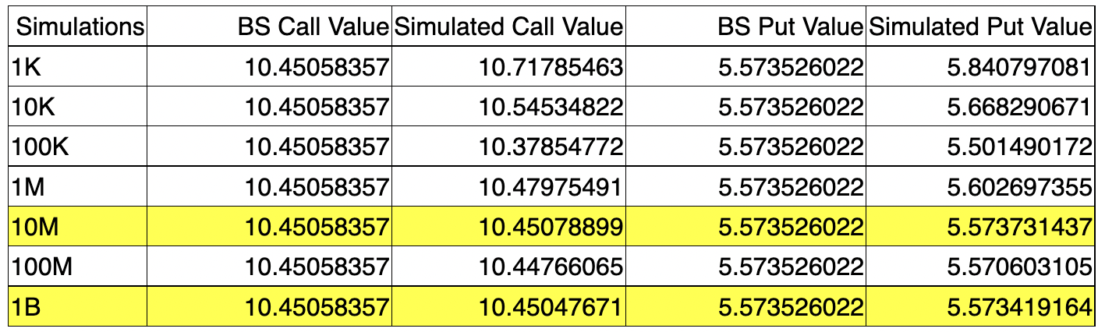Both Second Order and Third Degree Polynomial models were able to fit Implied Volatility for Option, though R2 of third degree polynomial is better but it is unable to generalise the fit.
* As the number of simulation increases, prices were more accurately matched.
* Monte Carlo Simulation and Simulation by Discretization were able to accurately match option prices.

# 

# Conclusion

The FX options market is one of the largest and most liquid OTC derivatives market in the world. The Black-Scholes assumption of constant volatility for all options is wrong. In professional FX markets, options with different moneyness levels and maturities are usually priced with different volatilities. A smile is a set of market implied volatilities plotted as function of the moneyness of the option, holding maturity constant. The vol smile evolves over time as options approach expiration. So, professional FX traders construct a vol surface, where implied volatilities are plotted as a function of moneyness and maturities. If the Black Scholes model was correct, then the vol surface would be flat.

# Future Scope

In future investigations it may be interesting to estimate the parameters under the empirical probability which are based on observations. That way we could have a more natural comparison between the modelled and empirical paths. Another extension of this work is to explore in more detail option pricing under the Heston model and estimate the parameters by implied volatilities. Further analysis can compare the estimated parameters using the discrete-time GARCH(1,1), which stands for generalized autoregressive conditional heteroscedasticity. This was discussed already in Heston’s original article.

# References

1. John C. Hull. Volatility Smiles. In: Options, Futures, and other Derivatives. Pearson; p 433-434.
2. National Stock Exchange. Equity Derivatives [Online]. Available from: https://www1.nseindia.com/products/content/derivatives/equities/fo.htm [Accessed 5th May 2020].
3. Nassim Nicholas Taleb. Volatility and Correlation. In: Dynamic Hedging: Managing Vanilla and Exotic Options. Wiley Finance; p 92
4. Rekhit Panchanekar. Heston Model: Formula, Assumptions, Limitations, and More Volatility [Online]. Available from: https://blog.quantinsti.com/heston-model/ [Accessed 5th May 2020].
5. Wu, Hsin-Fang. From Constant to Stochastic Volatility: Black-Scholes Versus Heston Option Pricing Models (2019). Senior Projects Spring; p 163.
6. Corporate Finance Institute. Option Pricing Models. [Online]. Available from: https://corporatefinanceinstitute.com/resources/knowledge/valuation/option-pricing-models/ [Accessed 5th May 2020].
7. Sonali Jain & Jayanth R. Varma & Sobhesh Kumar Agarwalla, 2019. [Indian equity options: Smile, risk premiums, and](https://ideas.repec.org/a/wly/jfutmk/v39y2019i2p150-163.html) [efficiency.](https://ideas.repec.org/a/wly/jfutmk/v39y2019i2p150-163.html) [Journal of Futures Markets,](https://ideas.repec.org/s/wly/jfutmk.html) John Wiley & Sons, Ltd., vol. 39(2); p 150-163

# Appendix

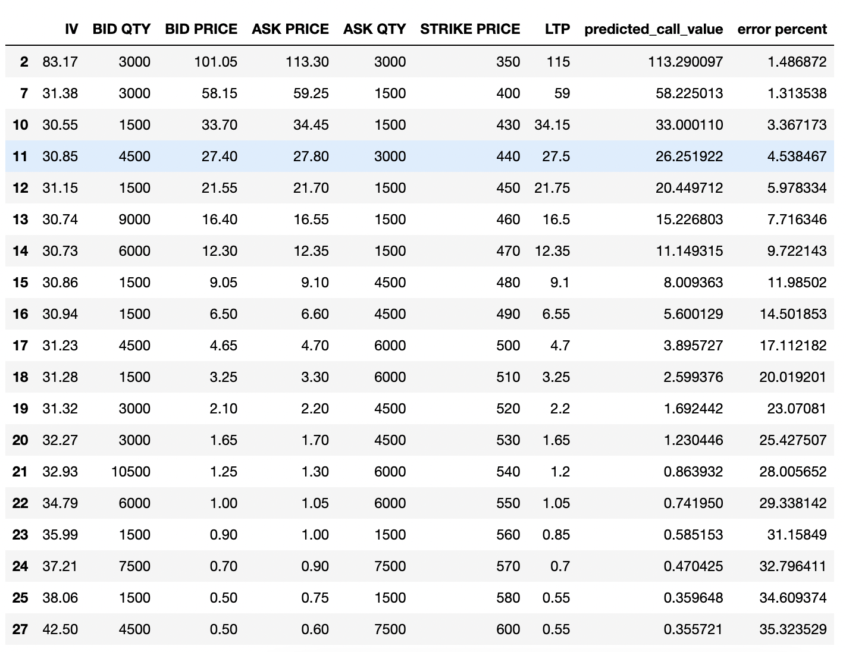

Figure 1 Matching Call Option Price for SBI using Black Scholes Model

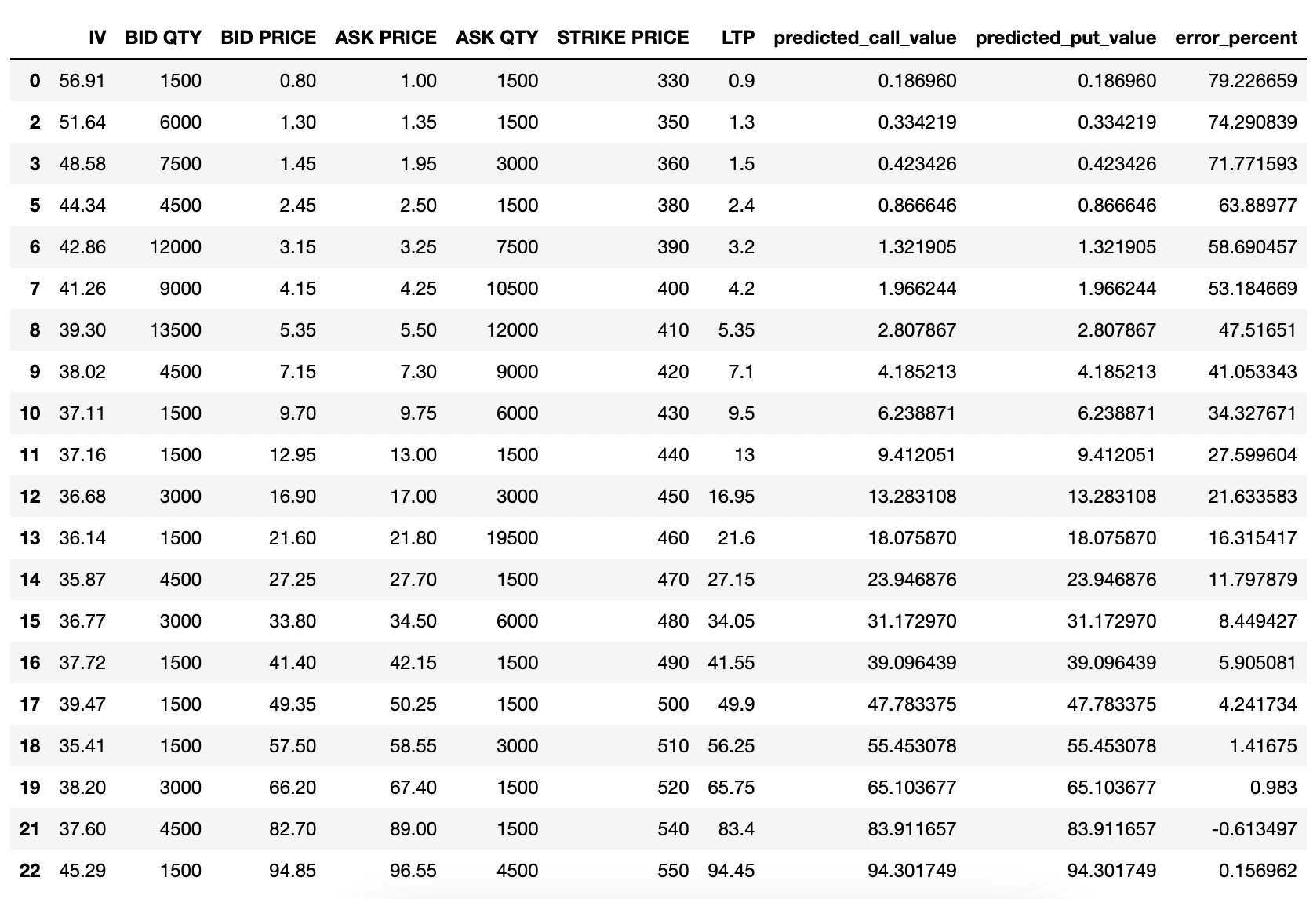

Figure 2 Matching Put Option Price for SBI using Black Scholes Method

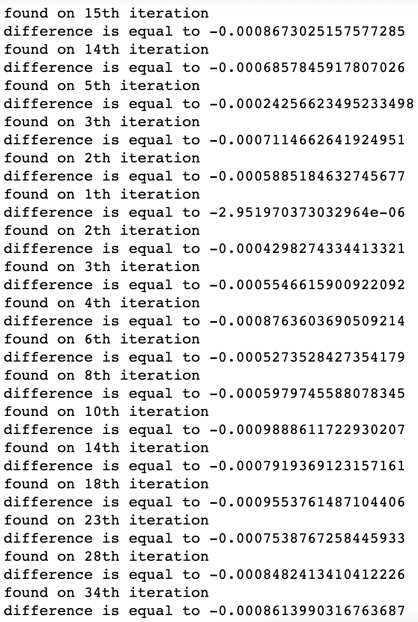

Figure 3 Matching Implied Volatility using Newton Raphson

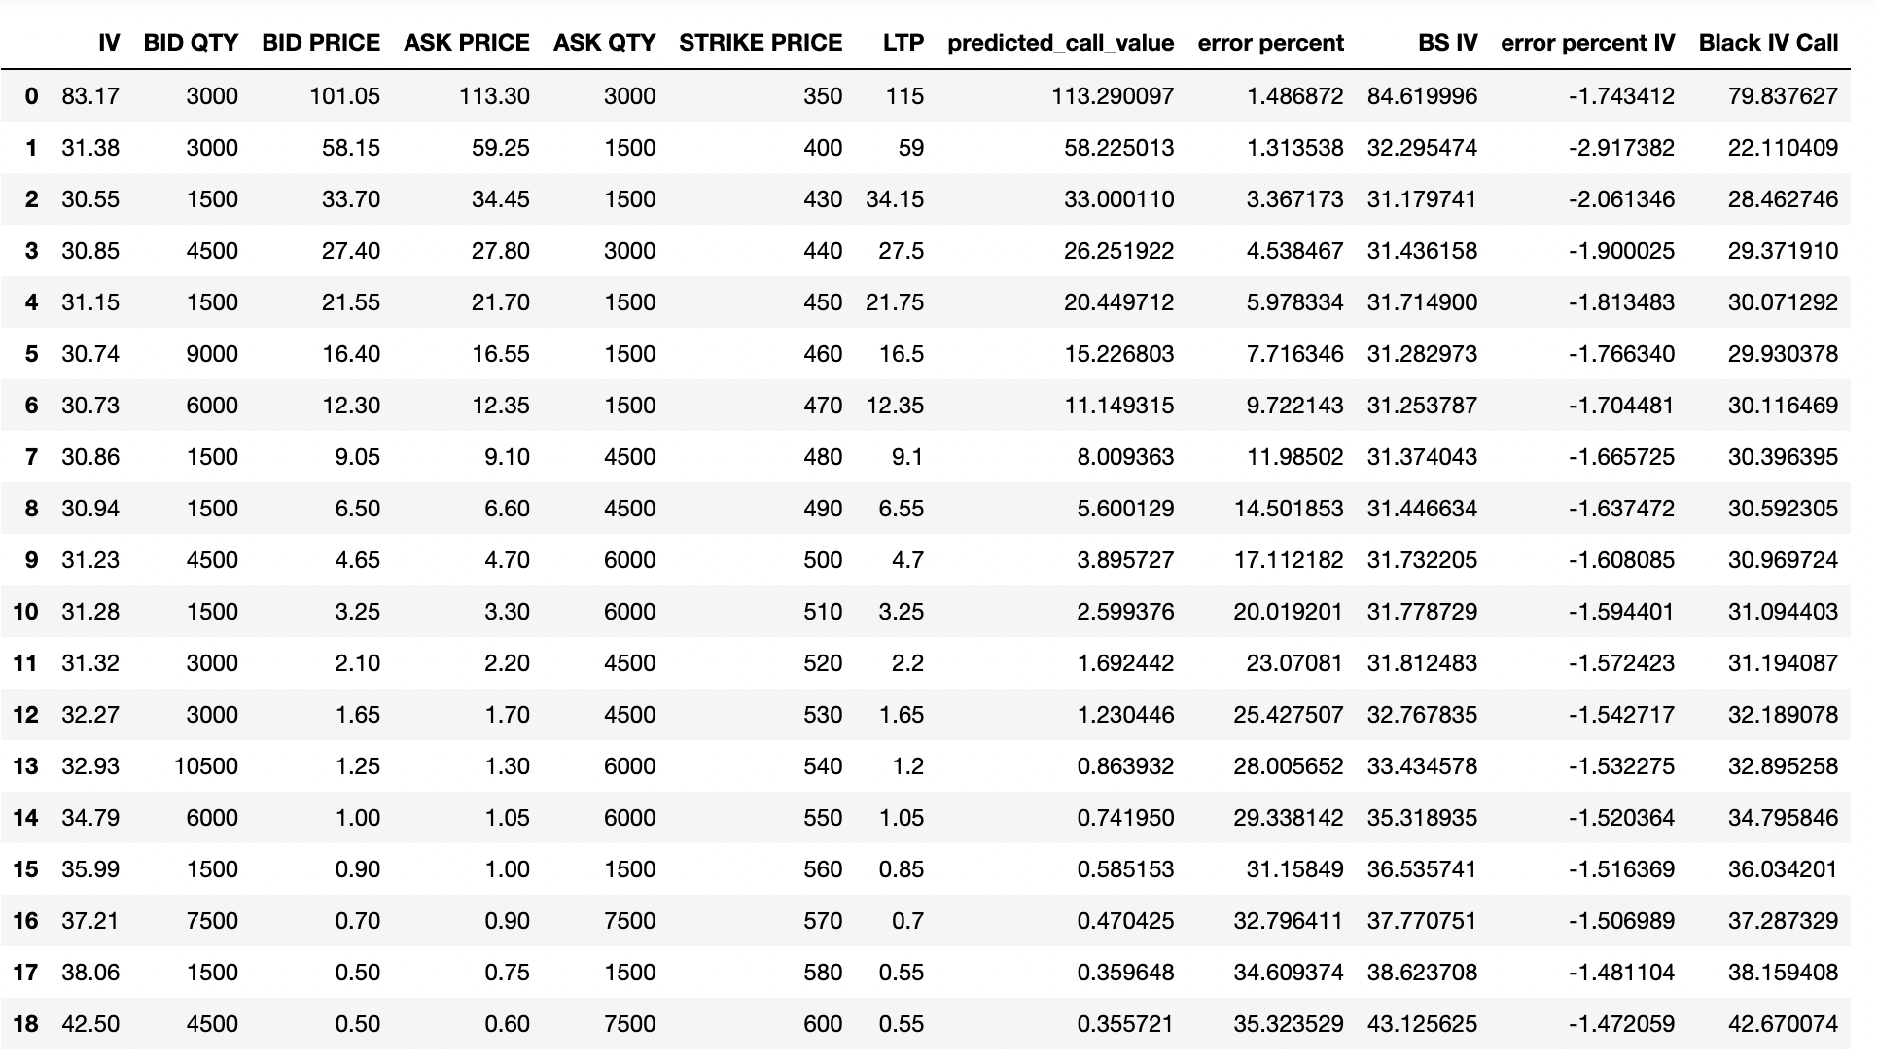

Figure 4 Matching IV using Black Model

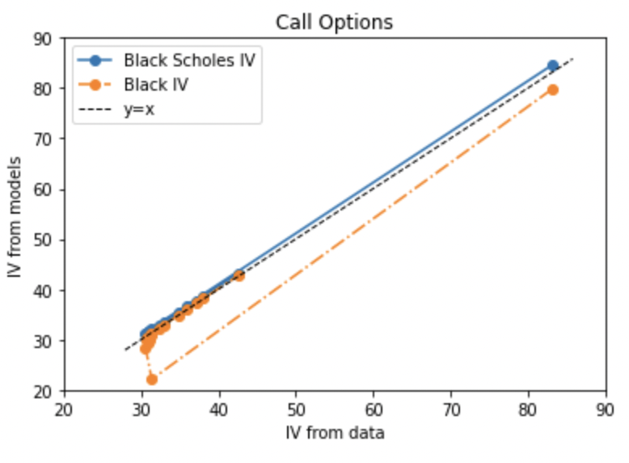

Figure 5 Comparing Black Scholes and Black Model IV

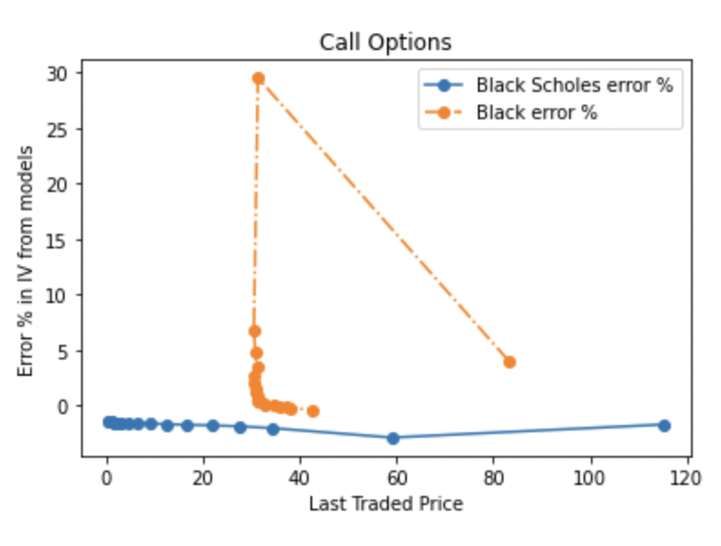

Figure 6 Comparing Option Prices using Black Scholes and Black Model

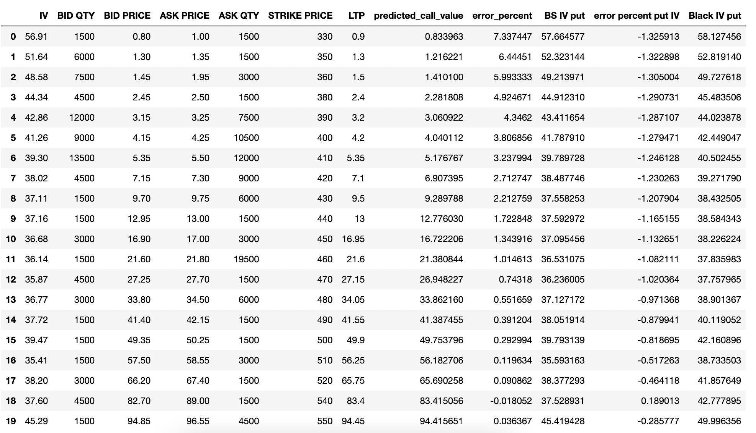

Figure 7 Comparing IV from Black Scholes vs Black Model

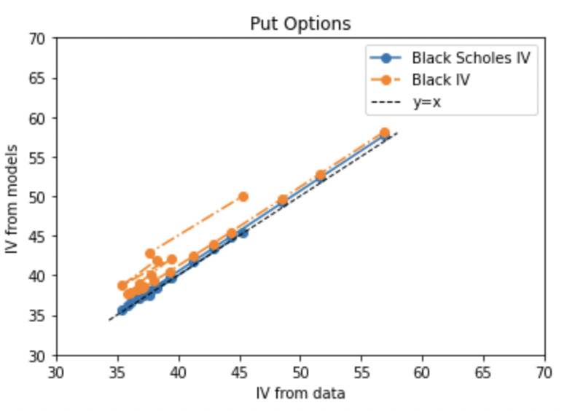

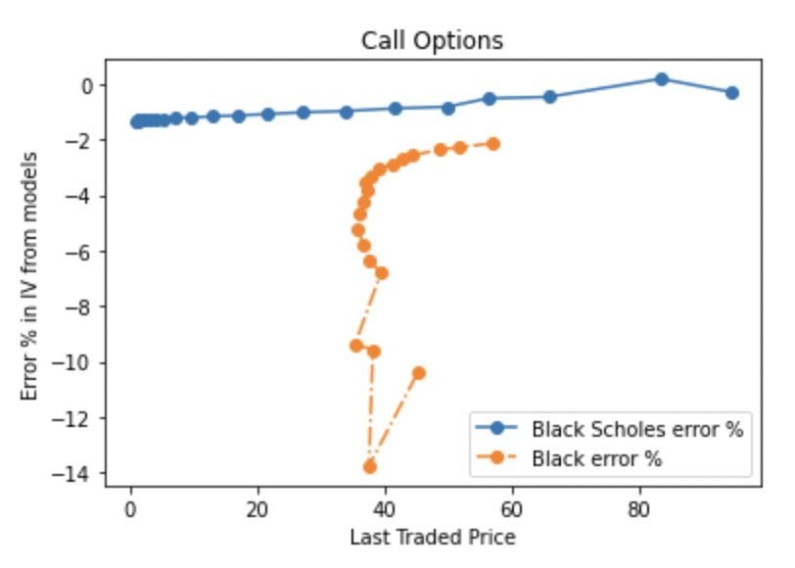Figure 8 Comparing IV from Black Scholes vs Black Model for Put Option

Figure 9 Comparing Put Option Price for Black Scholes vs Black Model

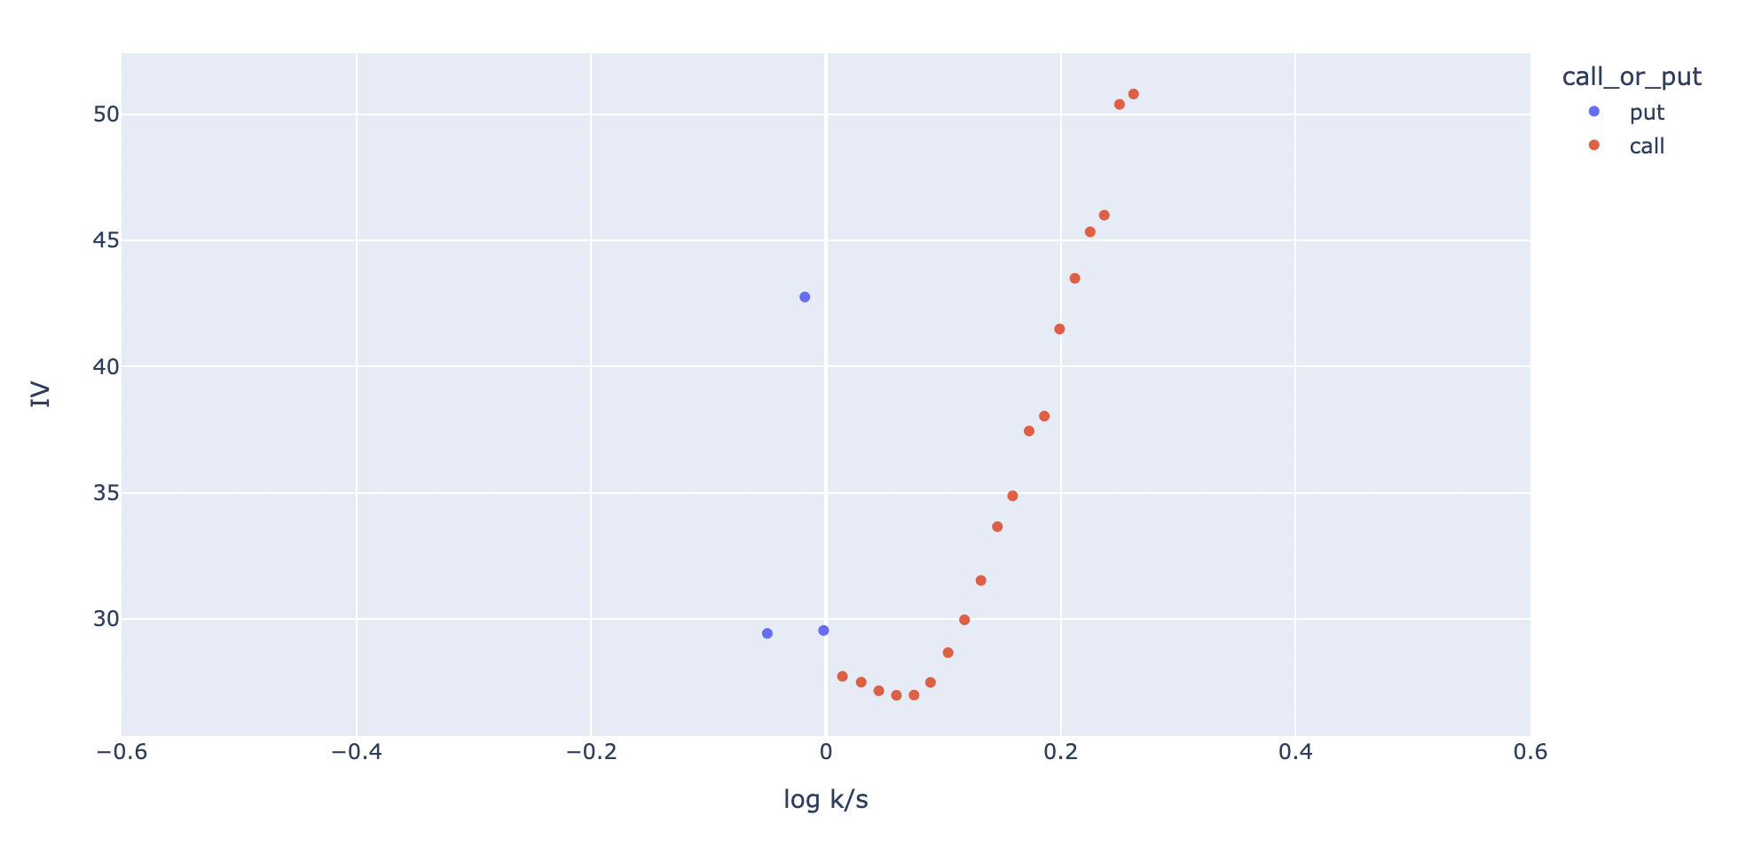

Figure 10 Volatility Smile for Axis Bank Option

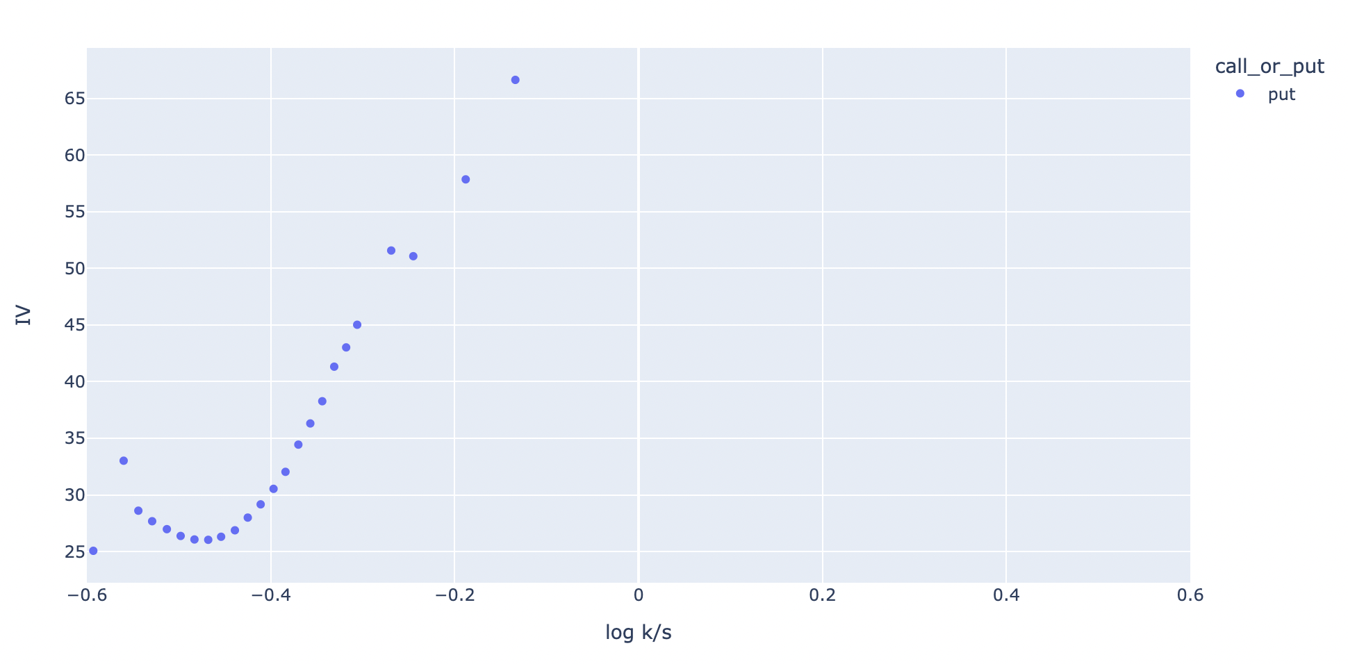

Figure 11 Volatility Smile for HDFC Bank Option

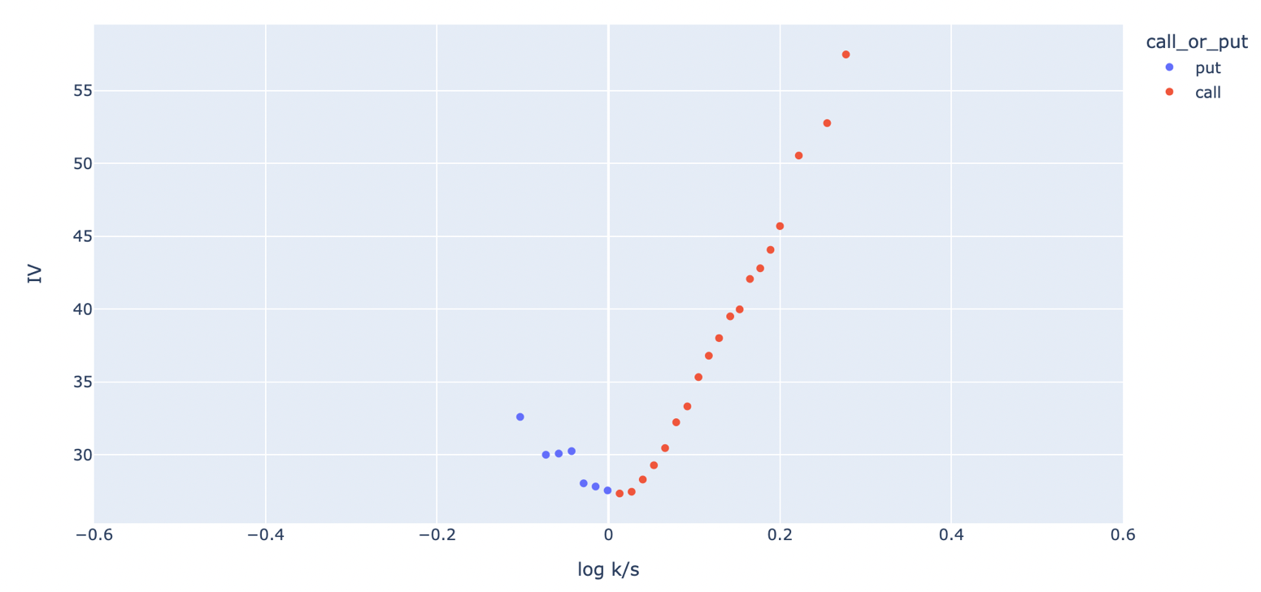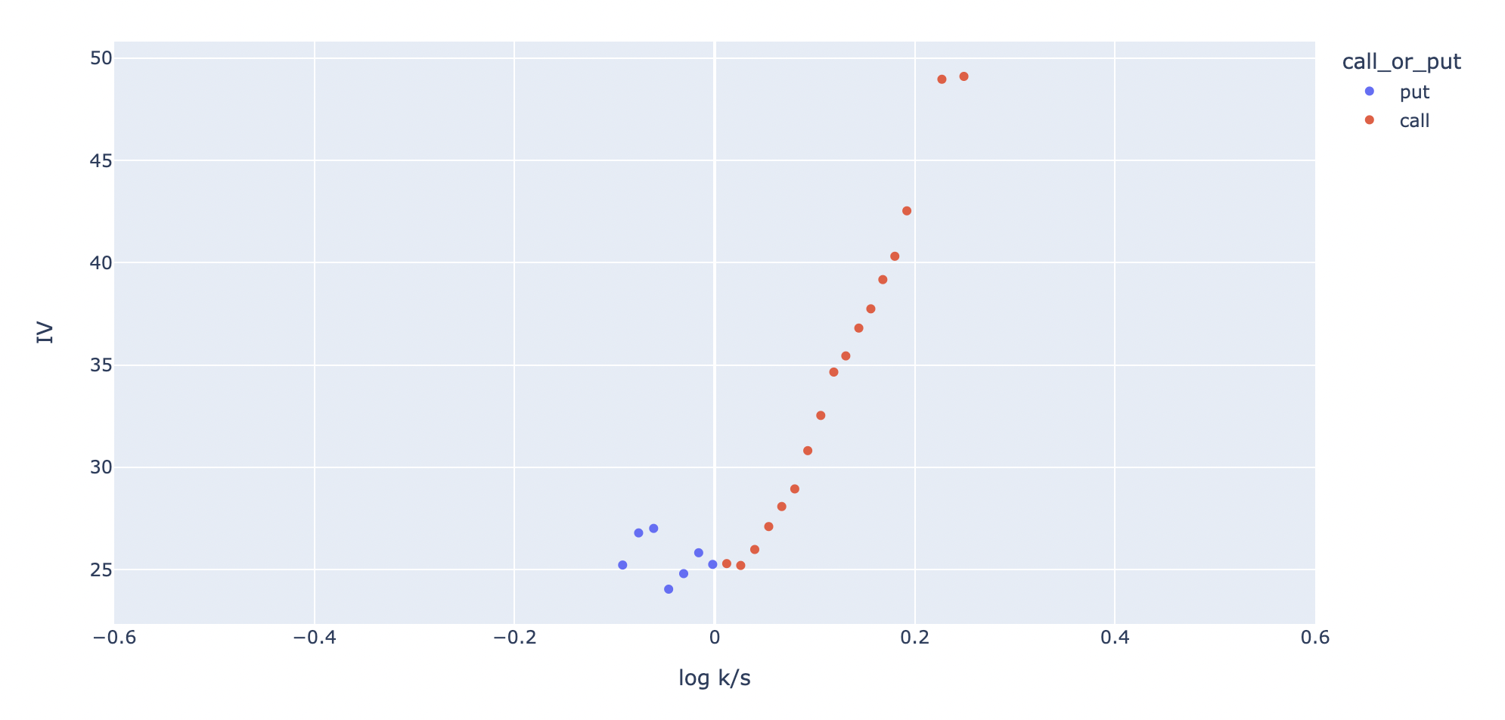

Figure 12 Volatility Smile for ICICI Bank Option

Figure 13 Volatility Smile for Infosys Option

Figure 14 Volatility Smile for ITC Option

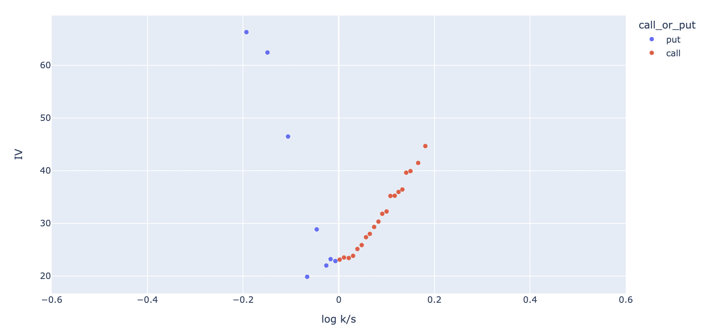

Figure 15 Volatility Smile for Airtel Option

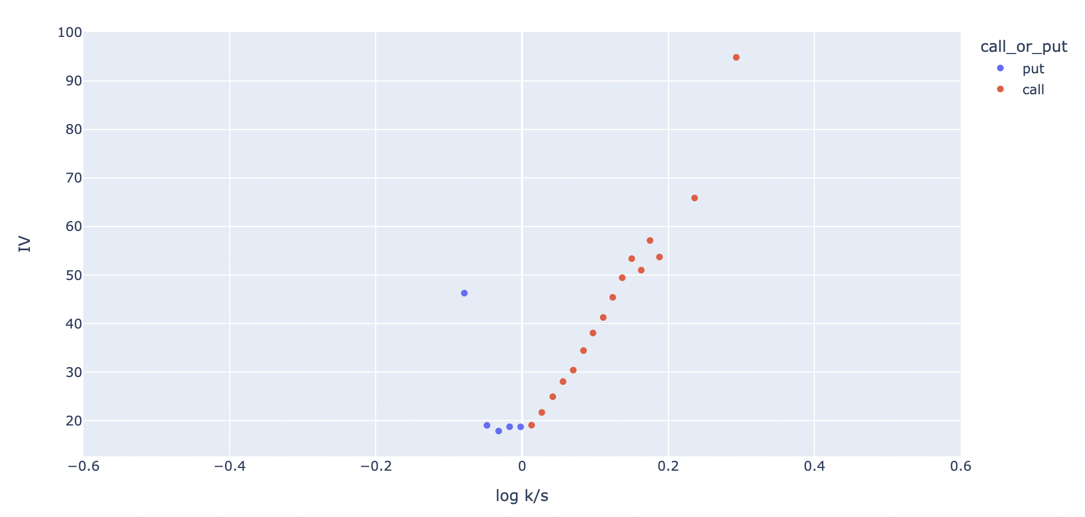

Figure 17 Volatility Smile for Indigo Option

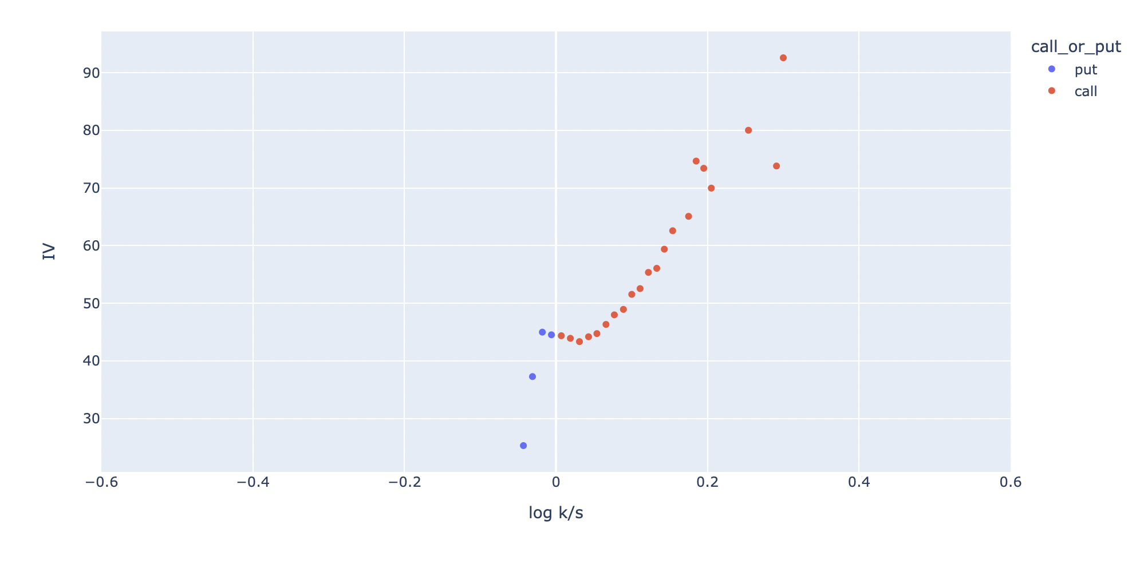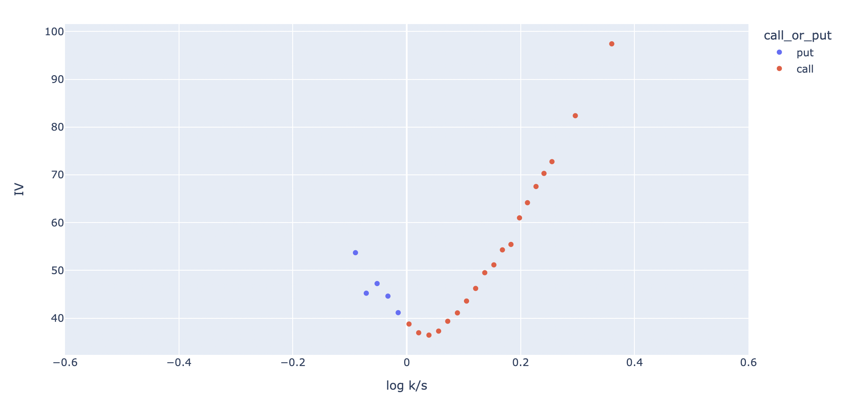

Figure 16 Volatility Smile for Bajaj Finance Option

Figure 18 Volatility Smile for NTPC Option

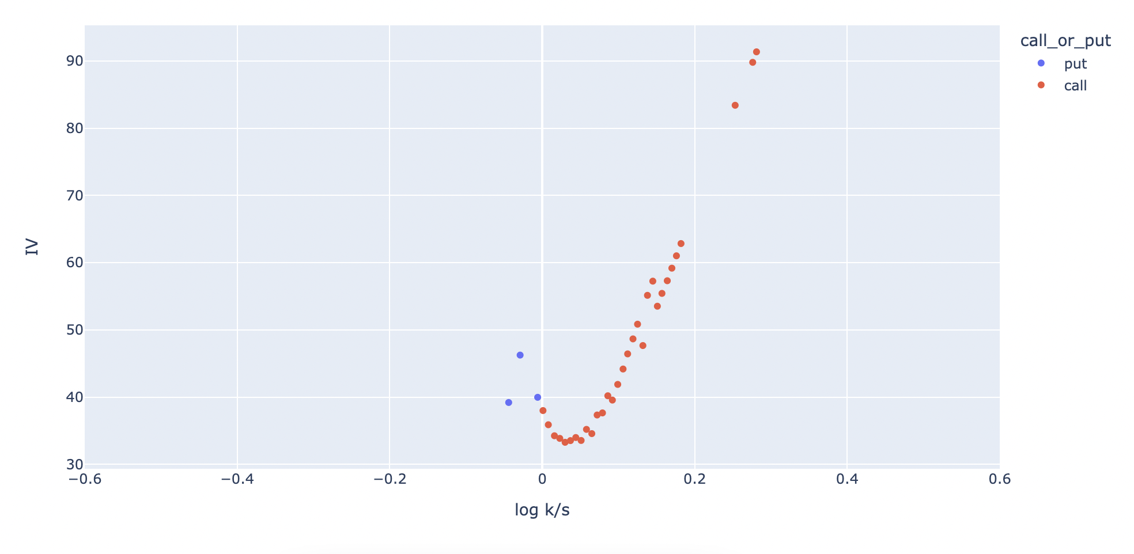

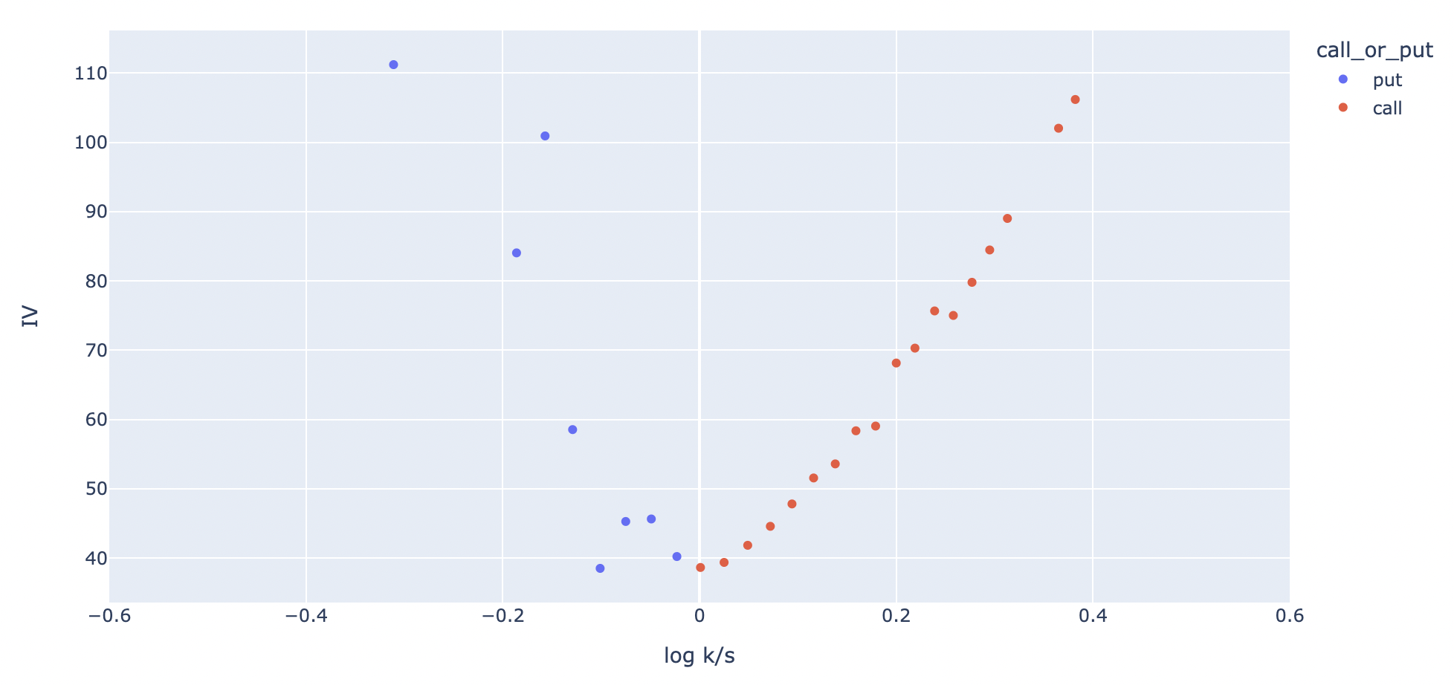

Figure 19 Volatility Smile for Tata Motors Option

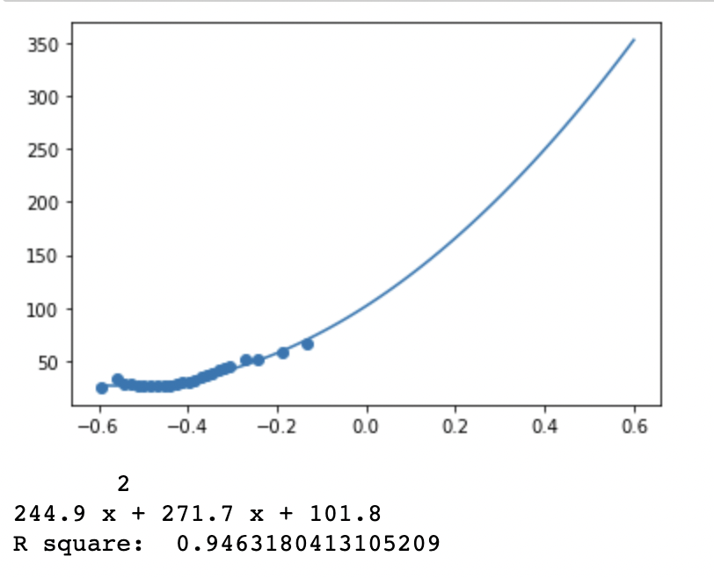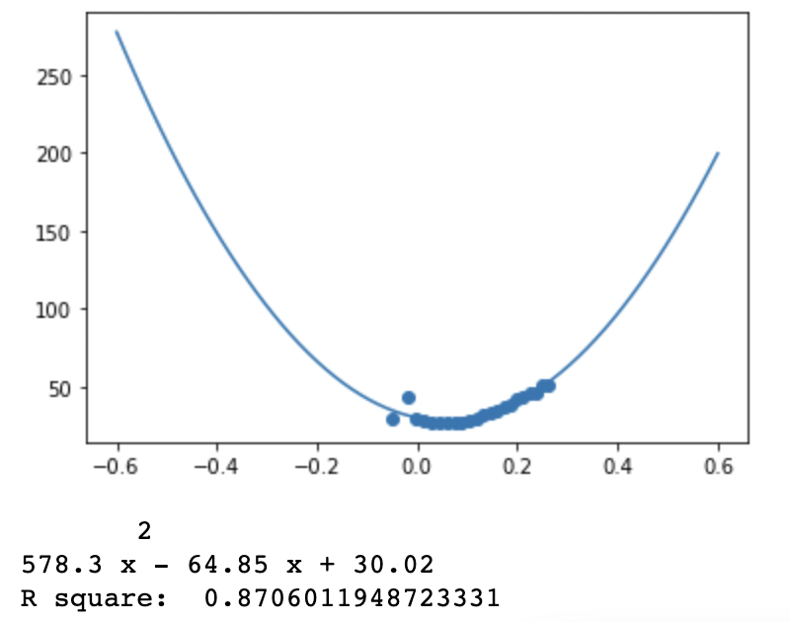

Figure 20 Axis Bank IV Quadratic Fit

Figure 21 HDFC Bank IV Quadratic Fit

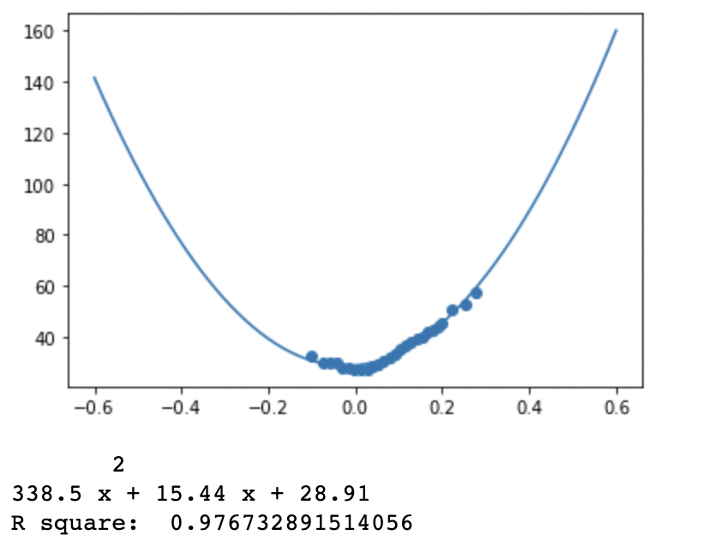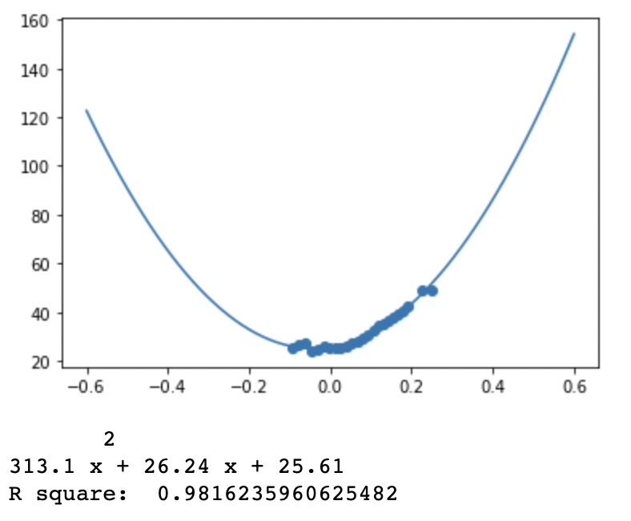

Figure 22 ICICI Bank IV Quadratic Fit

Figure 23 Infosys IV Quadratic Fit

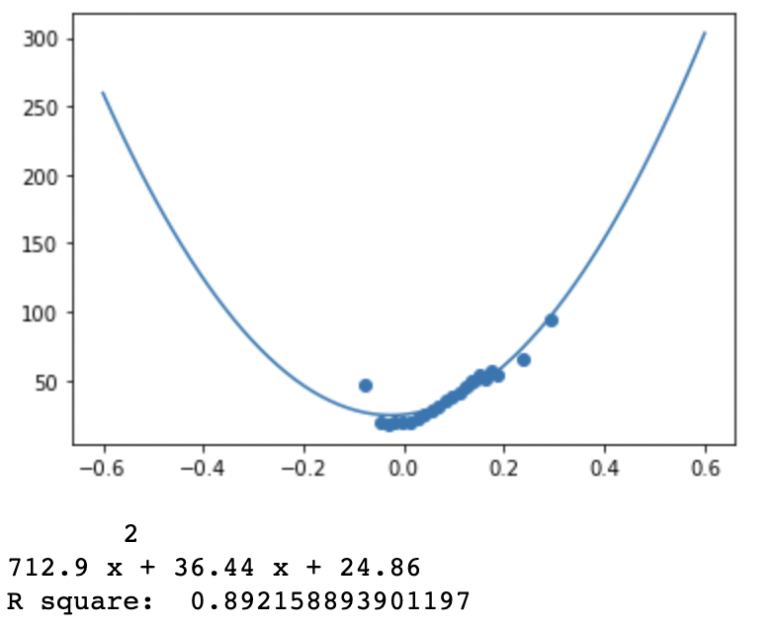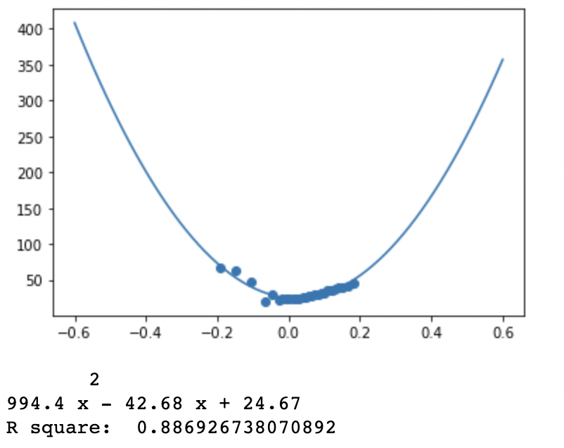

Figure 25 Airtel IV Quadratic Fit

Figure 24 ITC IV Quadratic Fit

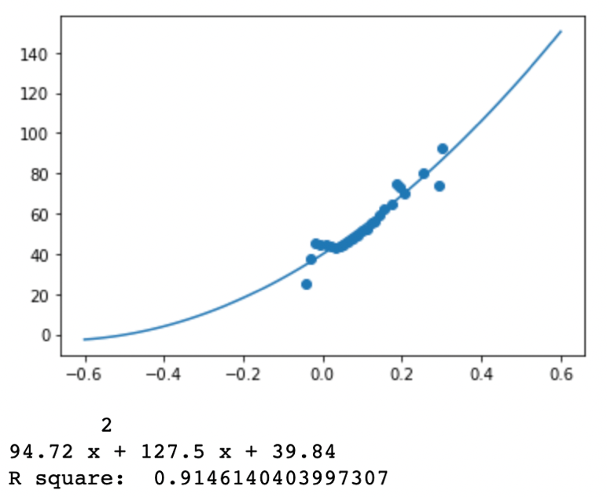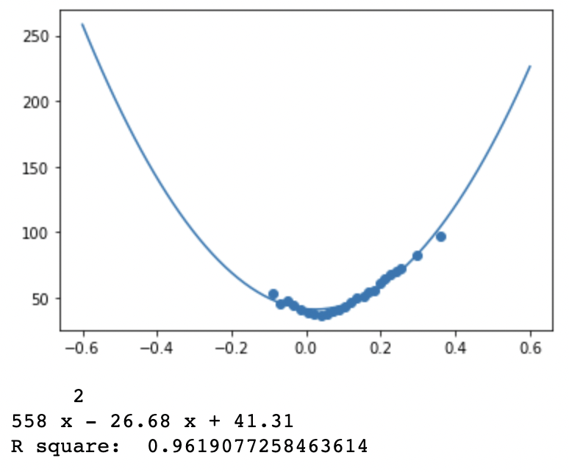

Figure 26 Bajaj Finance IV Quadratic Fit

Figure 27 Indigo IV Quadratic Fit

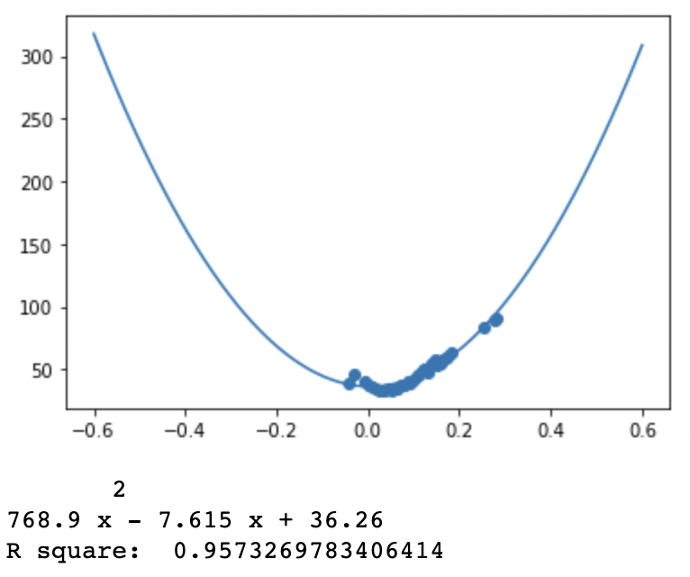

Figure 28 NTPC IV Quadratic Fit

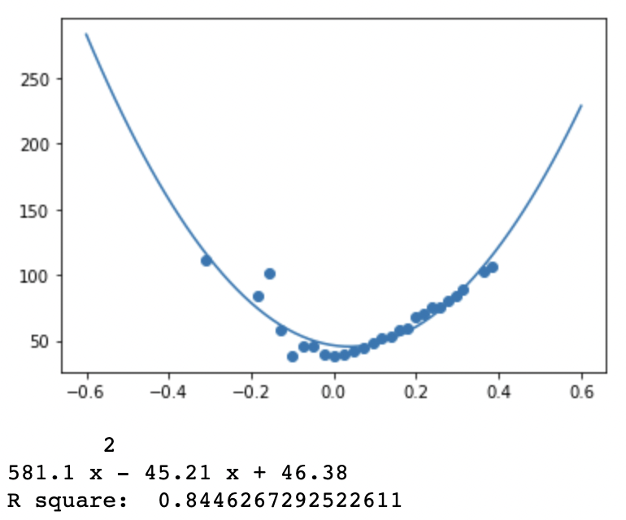

Figure 29 Tata Motors IV Quadratic Fit

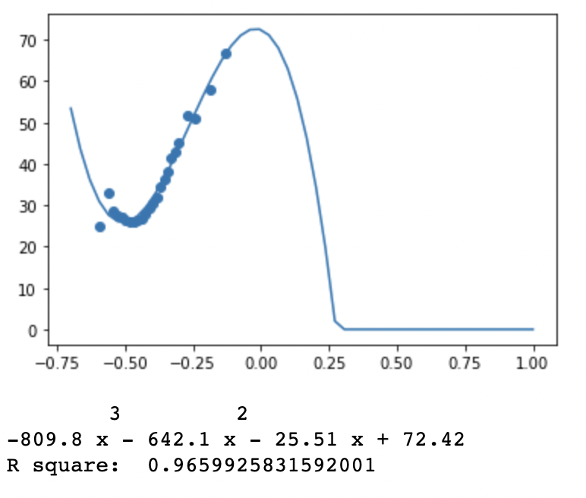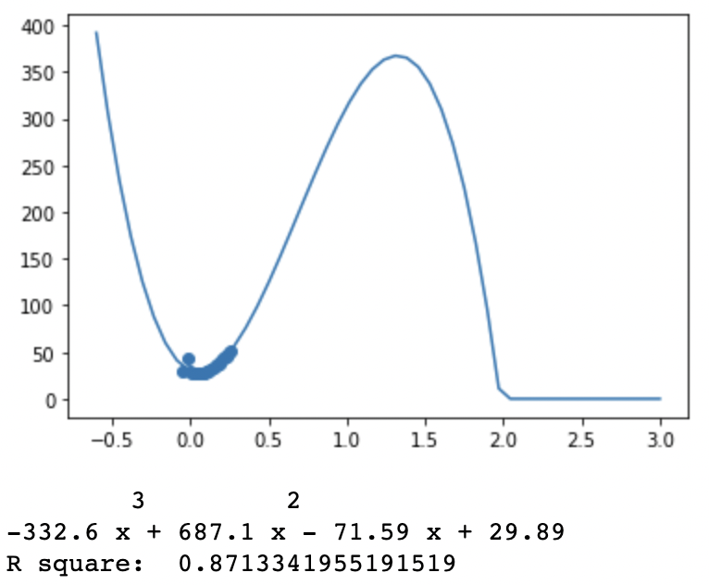

Figure 31 HDFC Bank IV Third Order Polynomial Fit

Figure 30 Axis Bank IV Third Order Polynomial Fit

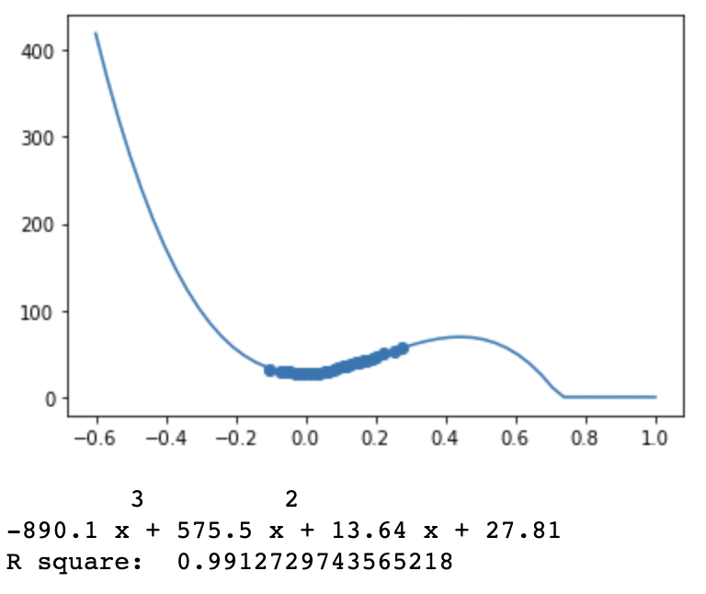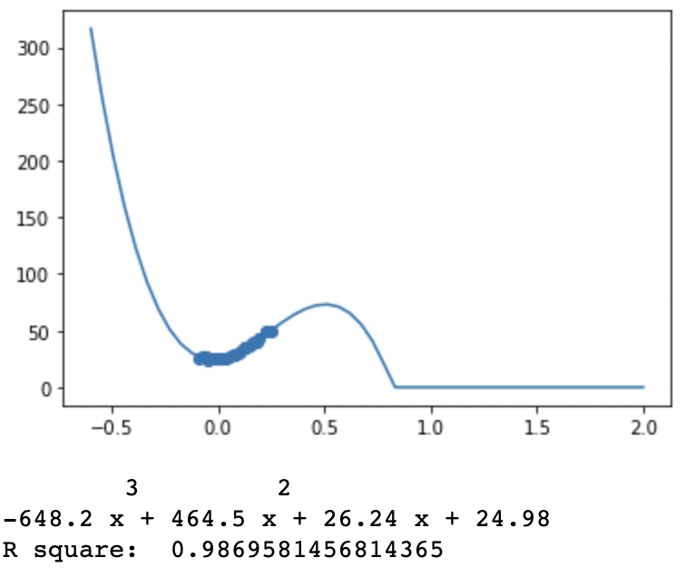

Figure 33 Infosys IV Third Order Polynomial Fit

Figure 32 ICICI Bank IV Third Order Polynomial Fit

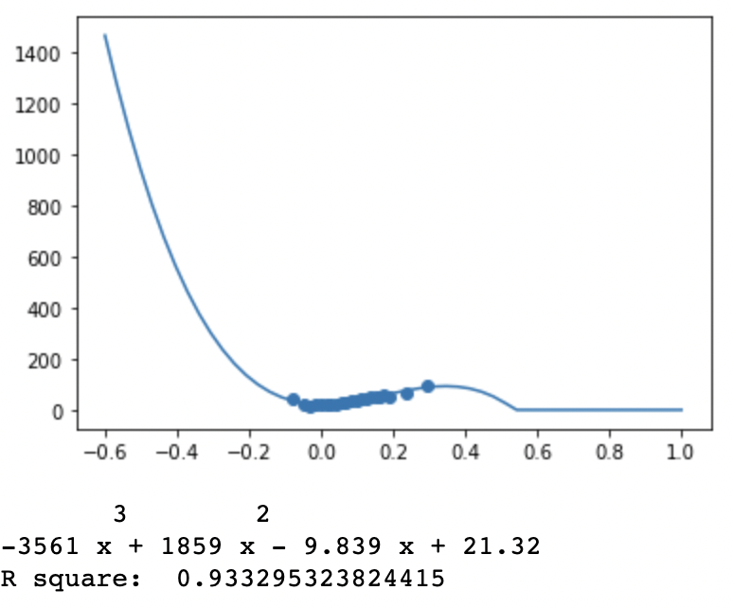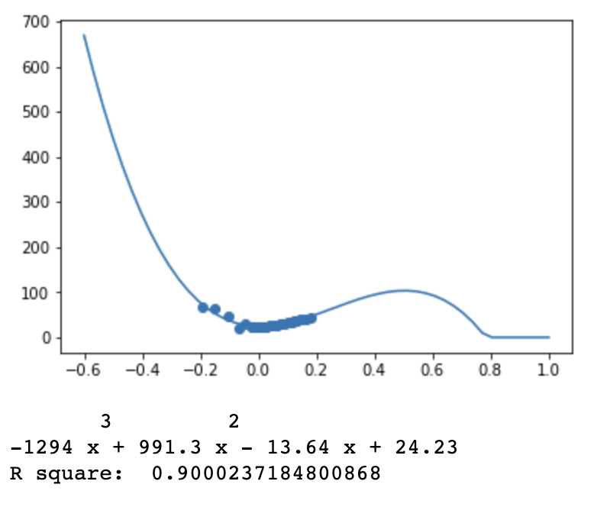

Figure 35 Airtel IV Third Order Polynomial Fit

Figure 34 ITC IV Third Order Polynomial Fit

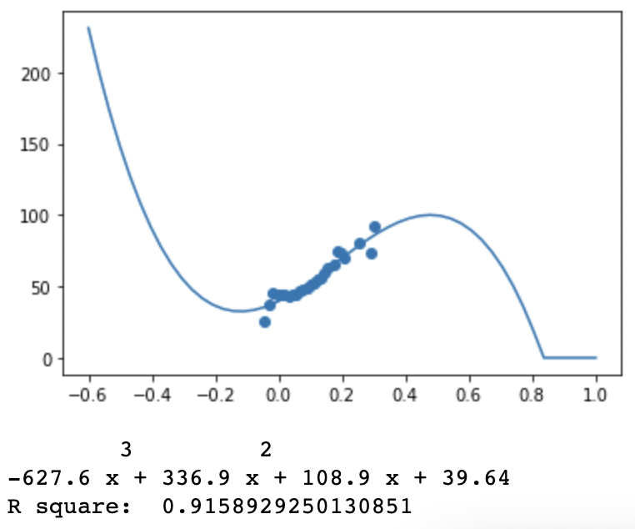

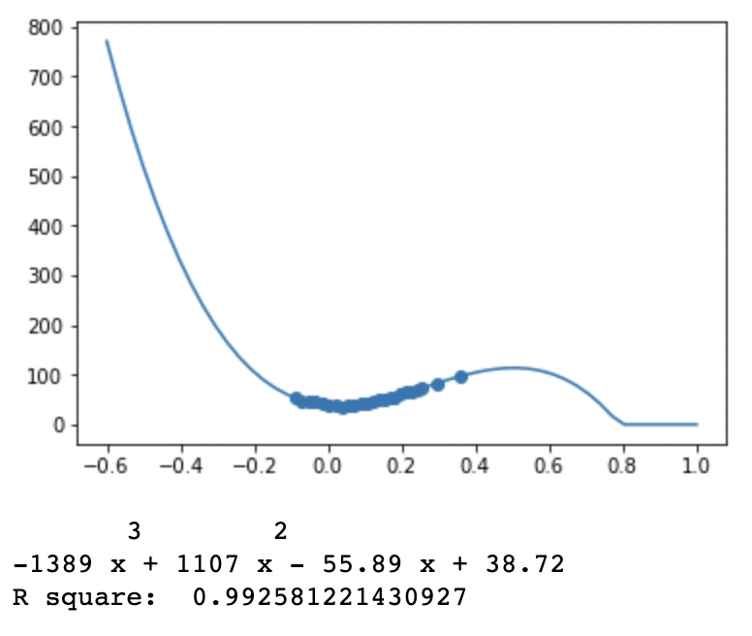

Figure 37 Indigo IV Third Order Polynomial Fit

Figure 36 Bajaj Finance IV Third Order Polynomial Fit

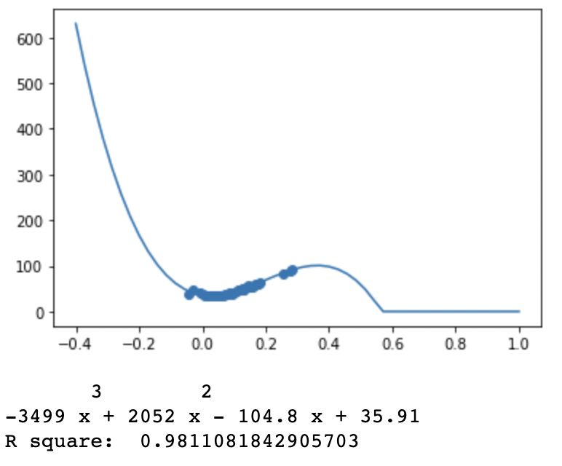

Figure 38 NTPC IV Third Order Polynomial Fit

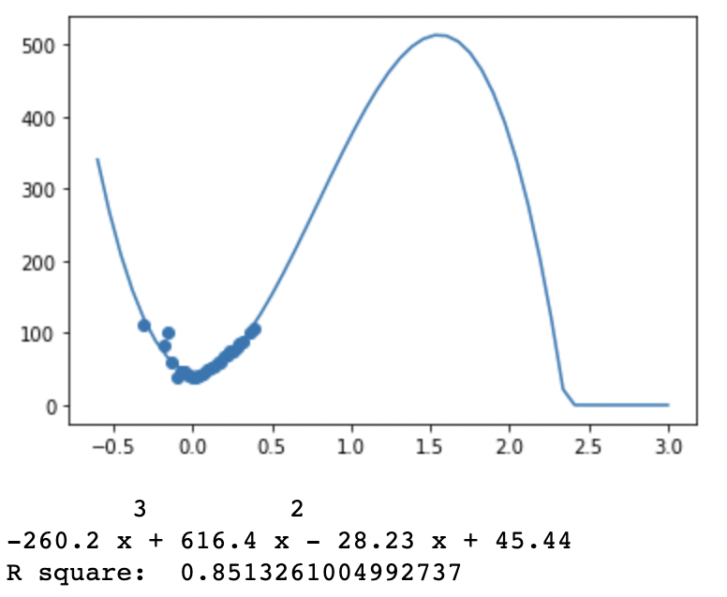

Figure 39 Tata Motors IV Third Order Polynomial Fit

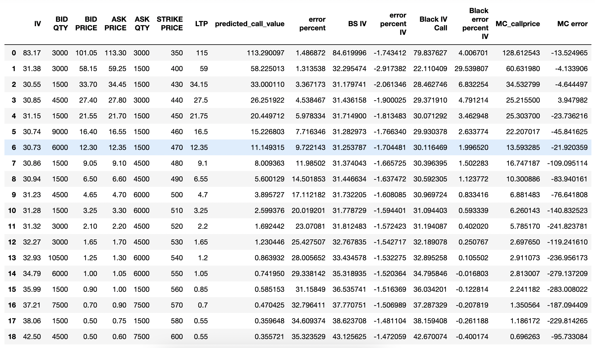

Figure 40 Option Pricing using Monte Carlo Simulation Method